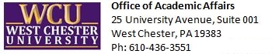
Date:

Academic Dismissal Appeal
Undergraduate Students

Instructions: Use this form to request a semester of continued probation following notice of an academic dismissal. Submit the completed appeal form via email to: dismissal@wcupa.edu.

Student Name: | WCU ID#:
Email Address: | Phone Number:
Continued probation requested to begin: Fall Spring Summer Winter

- Please explain the circumstances that led to your academic difficulties.
(Attach any additional documentation that assists in your explanation.)

- Please explain your plans to improve your academic performance.
(Attach any additional letters of support.)

- Statement of support (optional)
(If your advisor, chairperson, or coach wishes to submit a statement of support, they may do so here or attach a separate document.)

Dismissal Appeal Decision
(Academic Affairs Office use only)

Appeal approved. Conditions of continued probation:

Appeal denied. Reasoning and advisement:

Approving authority name: Approving authority signature: Date:

