INTERDISCIPLINARY MINOR IN SUSTAINABILITY & RESILIENCE
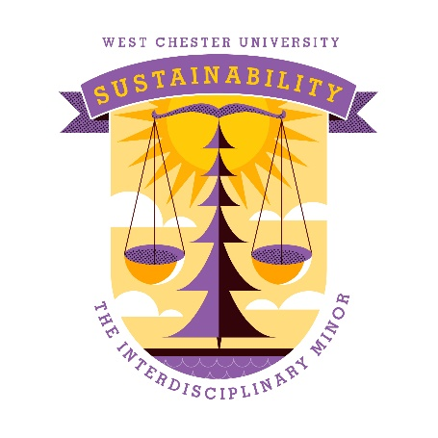
Advising sheet

Course list & requirements

Required courses:
- SUS100, Introduction to Sustainability & Resilience. Interdisciplinary designation.*
- SUS400, Sustainability Capstone: Application & Leadership. Writing emphasis designation.* Until we have enough students to be able to offer SUS400, we are substituting an internship, IDS450.
Four electives:
- can be sustainability pathway classes (gen ed)
- two must be upper level
- one must be a sustainability-related course in student’s major. You can choose from the approved list or make a case for counting a certain course to meet this requirement, since not all majors yet have sustainability-related courses.
- you may not take more than two courses with the same prefix.
- you may petition to have a class not on the list below count for an elective.
- approved electives:
ANT277/NTD277* - Sustainable Food Systems (no pre-req)
ANT367* - Archeology and Environment (PRE-REQ = ANT103)
BIO270 - Ecology (pre-req = BIO110)
BIO315 - Terrestrial Ecosystem Ecology (pre-reqs = BIO110, BIO215, BIO217, and BIO270)
BIO415 - Tropical Ecology and Conservation (pre-reqs = BIO110, BIO215, BIO217, and BIO270)
BIO471 – Wetlands (no pre-req)
BIO473 - Conservation Biology (pre-reqs = BIO110 and BIO215 or BIO217 and BIO270)
CHE403 - Chemistry of the Environment (pre-req = CHE104)
ECO385 - Environmental & Resource Economics (pre-reqs = ECO 111, ECO 112, and 2.50 GPA)
EDO400 - Environmental Sustainability Educ: History, Theory & Practice (no pre-req)
EDO415 - History Of Conservation (no pre-req)
EDO420 - Outdoor and Place-Based Education (no pre-req)
EDO425 - Independent Studies in Environment Educ (no pre-req)
EDO450 - Education for Sustainability: Methods and Field Experience (no pre-req)
EDO498 - Workshop In Environmental Education (no pre-req)
ENG305* - Environmental/Experiential Writing: Taking Action (no pre-req)
ENV324 – Environmental Sustainability (no pre-req)
ENV447 – Environmental Regulations (pre-req = ENV102)
ESS102* – Humans & the Environment (no pre-req), also SCB and ENV
ESS127 – Movies, Media, and Entertainment from an Earth and Space Science Perspective (no pre-req)
GEO205* - Geography of Agriculture, Food and Sustainability (no pre-req)
GEO230* - Environmental Conservation and Sustainability (no pre-req)
GEO332- Environmental Crises (no pre-req)
GEO334 - Sustainable Living (no pre-req)
GEO336 - Environmental Planning (no pre-req)
GEO338 - Environmental Applications of Geographic Information Systems (GIS) (no pre-req)
HON314 - Science, Technology and Environmental Systems (must be in an HON program)
MGT313* - Business & Society (pre-req = MGT200 and 2.5 GPA)
NTD325 - The Food Chain (no pre-req)
PAX200 – Introduction to Peace and Conflict Studies (no pre-req)
PHI451 - Religion and Ecology (pre-req = one PHI course)
PHI480 - Environmental Ethics (pre-req = one PHI course or instructor permission)
PSC325 – Campaigns and Elections (no pre-req)
PSC354 - Sustainability Politics and Policy (no pre-req)
RUX110 – Introduction to Urban Community Change (no pre-req)
SCI100 - Climate Change (no pre-req)
SOC245* - Environmental Sociology (no pre-req)
SOC309* - Sustainable WCU & Beyond (pre-req = SUS 100, SOC 100, or SOC 245)
WRH310 - Written Rhetoric: Power, Politics, and Environmental Writing (no pre-req)
WOS260* - Globalization and Ethics of Sustainability

*Course has also been approved as a General Education Sustainability Pathway course.
- other eligible classes (these can be approved by the director, but they will not automatically show up in your DPR yet because they have not gone through certain campus procedures):
ARH 401. Contemporary Art. (dept permission req)
BIO 277. Vertebrate Ecology. (pre-req)
BIO 476. Freshwater Ecology. (pre-req)
BIO 470. Population Biology. (pre-req)
CRJ 318. Environmental Crime. (pre-req)
CRJ 325. Animal Cruelty. (pre-req)
EXS 487. Physical Activity and the Environment. (pre-req)
ESS 127. Movies, Media, and Entertainment from an Earth and Space Science Perspective.
ESS 128. The Science of Natural Disasters.
ESS 336. Environmental Geology. (pre-req)
ENV 447. Environmental Regulations. (pre-req)
ENV 451. Environmental Toxicology. (pre-req)
ENV 462. Water Quality and Health. (pre-req)
MDC 420. Mass Media & Social Protest. (ethics, pre-reqs)
NTD 304. Global Nutrition.
NTD 305. Vegetarian Nutrition. (pre-req)
NTD 315. Food - Mind - Spirit. (pre-reqs)
NTD 415. Community Nutrition. (pre-req)
NTD 426. Farm to Table Food Product Development. (pre-req)
PAX 200. Introduction to Peace and Conflict Studies. (I)
PAX 377. Community Organizing: Strategies and Practice. (pre-reqs)
PHY 125. Theology and Science: Enemies or Partners.
PLN 316. Planning for Resilient Communities and Natural Disasters.
PLN 336. Environmental Planning.
PSC 325. Campaigns and Elections.
PSC 351. Energy and the Political Process.
PSC 371. State and Local Government.
PSY 400. Senior Seminar (special topic): Social Psychology of Climate Change and Dystopian Future
RUX 110. Introduction to Urban Community Change.
RUX 215. Liberation Psychology: Sustaining Community Change. (pre-req)
RUX 377. Community Organizing: Strategies and Practice. (pre-req)
WOS 260. Globalization and the Ethics of Sustainability. (D, E)
WOS 366. Gender, Labor and Globalization.

Sustainability minor planner

Course | Semester completed | Identify which course is in your major:
SUS100

SUS400 (current substitute = IDS450, Interdisciplinary internship)

Elective 1:

Elective 2:

Elective 3: 300-400 level

Elective 4: 300-400 level

