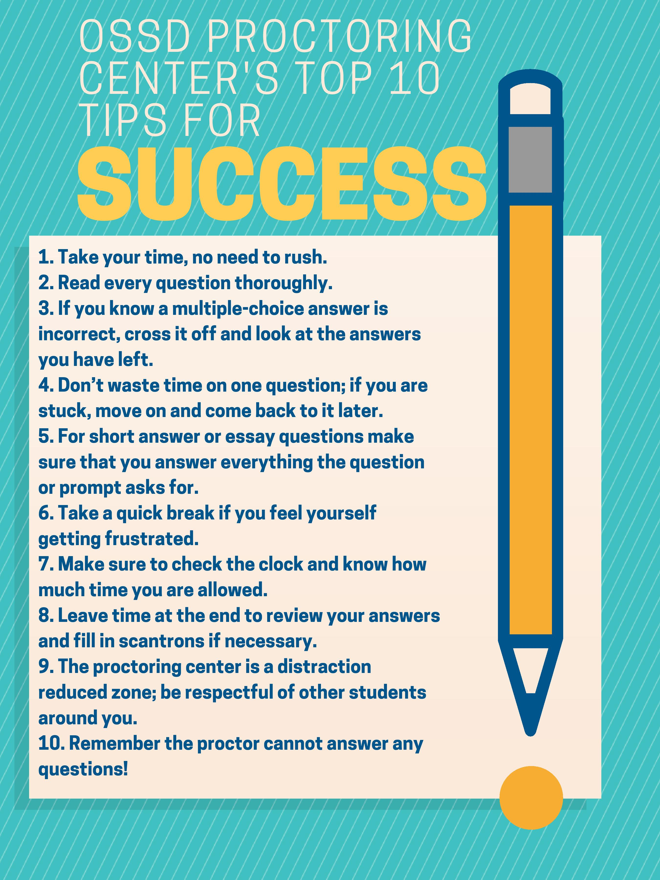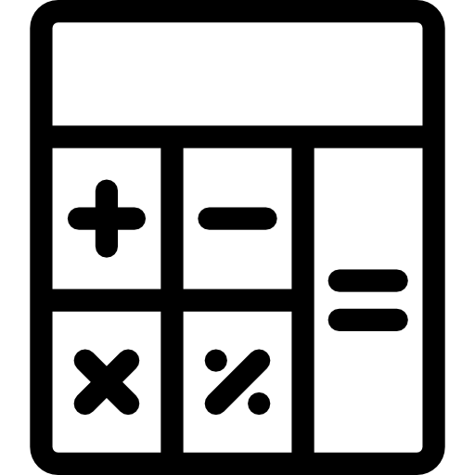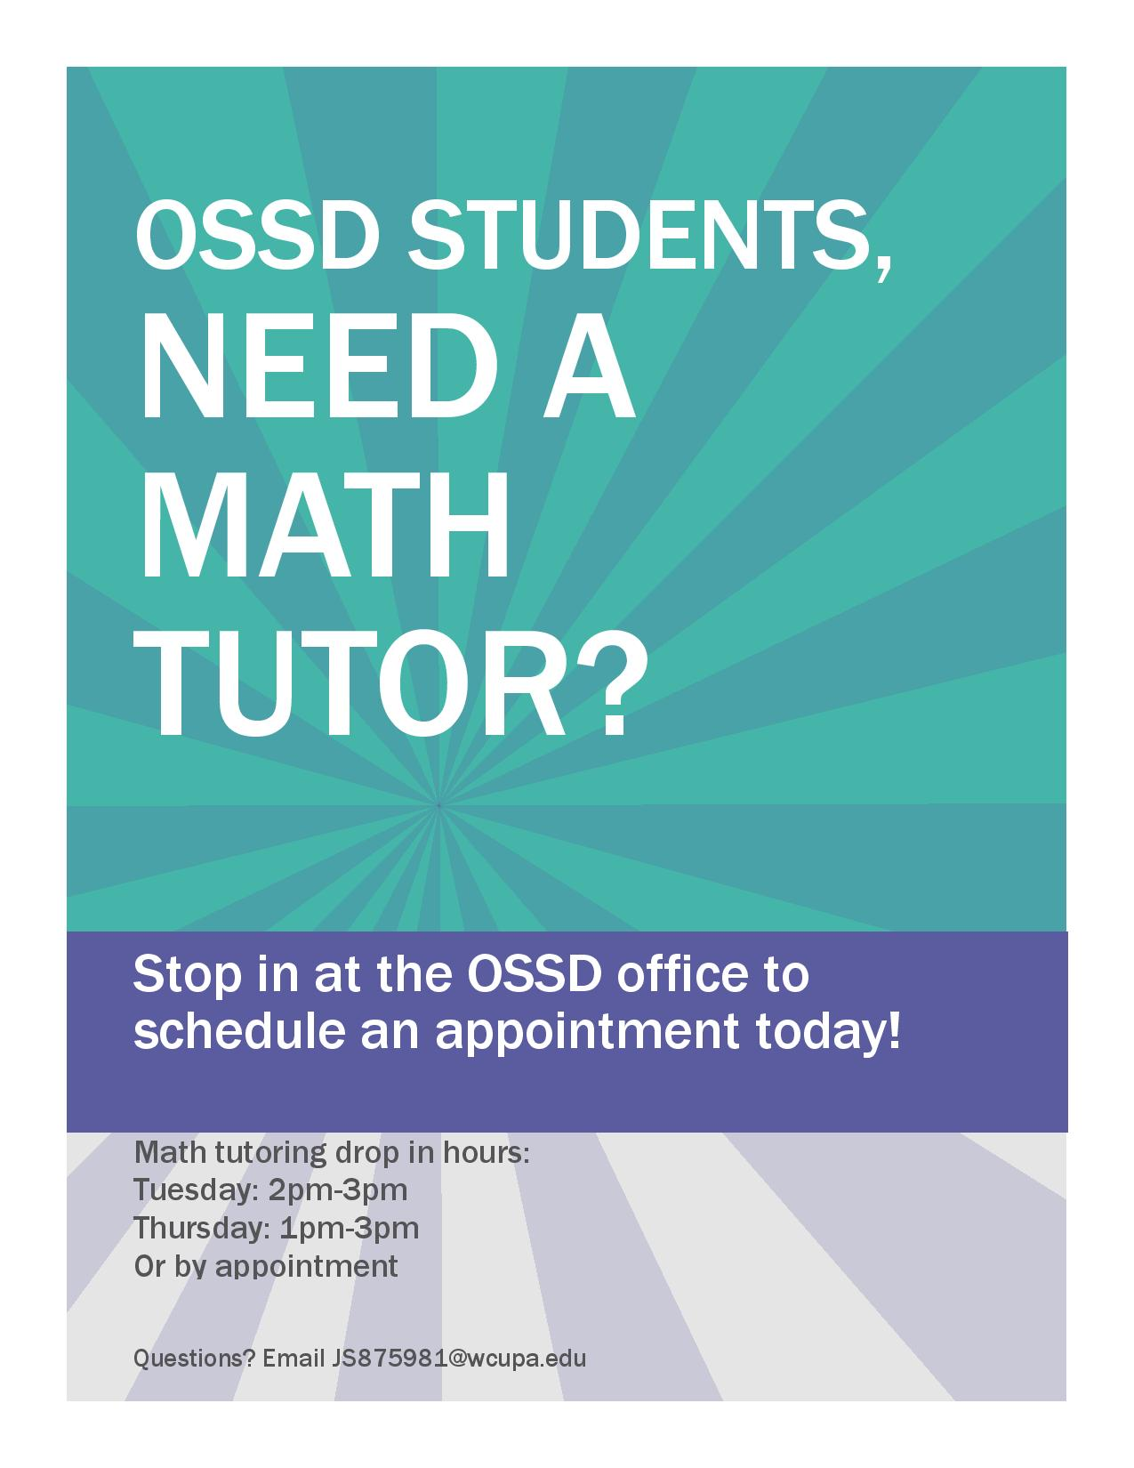

**Academic Coaching**

Academic coaches will work with a student on academic and life skills that affect their coursework and their academic progress. These skills include self-advocacy, time management, organization, career planning, etc.

**Math and Writing Tutoring**

Tutoring is available to improve the math learning experience through homework help, studying and test prep, as well as improve writing skills through all stages of writing including grammar, mechanics, etc..

**Adaptive Technology**

Audio Books, E-Text, Reading Technology, Dictation Programs, Notetaking Technology, and Alternative Texts

**Proctoring Center**Students who receive testing accommodations should speak to professors regarding testing arrangements. When professors are unable to accommodate students in a classroom, students will use the Proctoring Center.

### Our Student Resources

Office of Services for Students with Disabilities

# Need to contact us?

Advocate

705 South New Street

223 Lawrence Center

West Chester University

West Chester, PA 19380

610-436-2564 (phone)

610-436-2600 (fax)

www.wcupa.edu/UniversityCollege/ossd/

West Chester University

### the

SPRING 2019

Smart Study Strategies

Anxiety is a natural part of life. A little anxiety can be helpful in motivating us to finish our projects, get to class on time, and study in anticipation of tests. But too much anxiety causes a stress response, which can be toxic. Frequent exposure to stress can create greater sensitivity to stressors. Basically, this means that if you are already feeling stressed, when another stressor is added to your life, you may be less capable of handling it. According to HeySigmund.com, toxic stress can affect memory, cognition, and emotion.

There are a number of ways to combat this inevitable build-up of stress during midterm season. Maintaining a balanced diet, exercising, and staying connected to your important relationships can help to serve as a buffer. However, another way to strengthen your brain's defenses is to practice mindfulness. Mindfulness has been scientifically proven to help protect against stress, improving resilience and general well-being. Anxiety.org states that mindfulness helps us to be more present and aware of ourselves in the moment rather than reacting to the chatter in our minds. "By teaching awareness for one's physical and mental state in the moment, mindfulness allows for more adaptive reactions to difficult situations." If you aren't sure how to get started tapping in to the awesome effects of mindfulness meditation, sign up at the OSSD for a half-hour guided session on Mondays or Tuesdays!

# Anxiety About Midterms? Take a Mindful Moment!

When you’re feeling overwhelmed and stressed out, studying can often be a daunting task, especially if you have a disability. The good news is, there are several different strategies and techniques out there to help you make your studying more effective and less stressful.

The first and most obvious tip is to **avoid last-minute-cramming** at all costs. Instead of trying to reread all your notes and the textbook for hours on end before your test, try to study in 30 minute chunks each day leading up to the exam. You will find this to be way more manageable and realistic, while also retaining more of what you need to know.

**Reviewing and breaking down your notes** after every class session will make studying much easier, too. By breaking the lecture material down in your words, it’ll stick in your head better and will be easier to memorize for a test. Compare and contrast the original notes from your broken down ones to really comprehend them.

Another studying method that works well is to **review your material 10-15 minutes before bed**. Many studies have proven this to be effective for memorization. This should not replace the bulk of your studying, but getting in this habit is a very helpful and low maintenance way of remembering the material.

Last, but certainly not least, **the most important tip of them all is to make sure you are prioritizing your general well-being**, because if you don’t, everything else will suffer, including studying. Having 7-8 hours of sleep and regular exercise will naturally increase your focus, which will naturally help ensure your studying more efficiently. Listen to your body before anything else, and take small breaks and naps as you need them for ultimate study success.

**Helpful Tools:**

***To set goals:***

Learn how to set SMART goals: those that are Specific, Measurable, Achievable, Relevant, and Time-bound.

***To create and manage lists:***

Wunderlist ([https://www.wunderlist.com/)](https://www.wunderlist.com/)%E2%80%93): Organize and share lists and tasks, get reminders, and assign items to others with this user-friendly app. (Subscription might be needed)

***To increase productivity:***

Toggl (<https://www.toggl.com/>): Use this free web-based time-tracking app to create tasks and then track the time you spend on them, so you can see where your time is going and adjust if needed.

Enjoy free time and accomplish more by planning ahead and using your time wisely. Follow these time management tips and strategies to ensure that you meet deadlines and are well prepared for exams.

* ***Identify Time-Wasters and Set Goals***

It’s easy to get distracted. Pay attention to what draws your focus away from your studies and assignments. Instead, use those activities as a reward for staying focused and accomplishing the tasks you set out to complete.

* ***Plan Ahead by Creating a To-Do List***

Identify what you need to do, and then prioritize the tasks based on when the assignment is due and how much time you need to complete it. This gives you a set plan for the day. Unless there’s a pressing priority, it’s important to also consider what sort of work you’re in the mood to do.

* ***Tackle Small Tasks to Start***

It’s easy to get overwhelmed by large projects and big exams, and the anxiety can make you want to procrastinate. Start with shorter, simpler to-do items and then move on to larger projects or assignments.

* ***Only Do One Thing at a Time***

No matter what, don’t switch to another task until the one before it is complete. This may be a hard habit to break, but it’s worth it.

* ***Establish Routines***

The more often you do this, the less you’ll have to think about when you’ll accomplish the tasks you need to finish that day.

* ***Take Time Off***

It’s important to take time for yourself. Long study sessions or chunks of time working on assignments should be broken up with time away from screens or textbooks. You need to give your mind a rest.

Time Management

For Busy Students

**Upcoming Spring 2019 Events for the Career Center:**

* **LinkedIn Panel – Leveraging Your Professional Presence in the Digital Age** will be located in the Sykes Student Union Theater from 3:30pm to 5:00pm on March 27, 2019.
* **Meet Your Major: Sophomore Connection** will be located in the Sykes Student Union Ballrooms from 5:30pm to 8:30pm on March 27, 2019. *Only open to students with 30 to 60 completed credits.*
* **Marketing and Communications Meet Up** will be located in the Sykes Student Union Ballrooms from 4:00pm to 6:00pm on April 1, 2019. *All majors are welcome!*
* **Science and Health Meet Up** will be located in the Sykes Student Union Ballrooms from 4:00pm to 6:00pm on April 1, 2019. *All majors are welcome!*
* **Etiquette Dinner** will be located in the Sykes Student Union Ballrooms from 5:30pm to 7:30pm on April 10, 2019. *Seating is limited and reservations are required.*
* **Interview Night for Education Majors** will be located in the Sykes Student Union Ballrooms from 4:30pm to 8:00pm on April 23, 2019. *Education Majors only. Apply through Ram Career Network.*

A message from the

Twardowski Career Development Center

Your career development is important to us!

The Twardowski Career Development Center is a welcoming and open space for students of all majors and all class years. We encompass a student centered approach, and strive to inspire and empower you as an individual throughout your career development process. We are here to support your evolving career aspirations. Whether you are exploring a major or minor or considering career options, we have the resources to assist you.

If you feel unsure of where to start when it comes to resume or cover letter writing, let us help. We offer in-person resume and cover letter reviews as well as email reviews. As a WCU student, you automatically have a career profile, which is called Ram Career Network (RCN). This can be accessed through our website at wcupa.edu/cdc, and RCN is an additional place for you to have your resume reviewed. All you have to do is upload your document through the “*Documents*” tab and it comes right to us!

RCN also includes a job and internship search function as well as information about our upcoming events. Look under the “*Resources*” tab to complete online practice interviews.

We offer job and internship search assistance, and can provide you with tips on professionalism and networking. If you are interested in connecting with a career professional, please stop by Lawrence 225, call our front desk at (610) 436-2501 or send us an email at [cdc@wcupa.edu](mailto:cdc@wcupa.edu) to schedule an appointment. We also hold drop-in hours, (no appointment needed) Monday-Friday from 1pm-3pm.

For more information about our services and resources, please visit our website (wcupa.edu/cdc). We are happy to support your career development – now, as students, and in the future, as alumni. Happy Spring semester!

Here are some important when it comes to learning

from math:

1. Mistakes help you learn, as long as you review them and understand what went wrong. By doing this, you are less likely to make that same mistake in the future.
2. Don’t try to memorize math. You are less likely to be able to recall anything if you just memorized the equations for the test.
3. There are almost always multiple pathways to get to an answer, so find which path works best for you.
4. If you are struggling with a certain type of problem, practice that type of problem. Try to find the multiple pathways and practice solving the problem differently.
5. Make flash cards for vocabulary and review them once a week. Include examples in your definitions so that you can see the word in action.
6. Try applying the problem to a real-world situation. If you make that connection, you are more likely to understand the problem.
7. Make a study group. If you have people to talk out the problems to you are more likely to see the errors in your thinking and fix them on the spot.
8. If you keep getting stuck on a challenging concept, ask for help. You could ask the people around you or get a tutor.
9. Have confidence in yourself. Remember, there is no such thing as a math person, everybody can do math if they put their mind to it!

# Reading

# Comprehension Tips!

**Figure out your ideal reading environment**

Do you need silence to read? Find a quiet place like your bedroom or acquire ear plugs. Do you read best when there’s white noise in the background? Trying reading in the Library or a coffee shop. There are even some apps and YouTube videos you can use to create the perfect white noise atmosphere.

**Write notes instead of highlighting**

Highlighting can be a useful tool, but in the end, it doesn’t do much to help your long-term memory retain the information you’re reading. Instead of highlighting important information, try writing it down in your notes. That way, your brain spends more time thinking about the information, and you can record any questions you want to bring to class.

**Read aloud**

If you’re the kind of person whose mind wanders when you read, reading out loud can help your brain stay in the moment. Anything from muttering to yourself to reading to a friend can be helpful. Absorbing information visually and auditorily can help your brain focus on and retain the information.

**Use an index card**

Sometimes when we go to read a large text, it can feel overwhelming and hard to focus on one sentence. If that happens, try using an index card to track the sentence your reading. Cover all the text below the sentence you’re on with the index card and move it down as you read to make it easier to take in the information.

# Math Homework Tricks

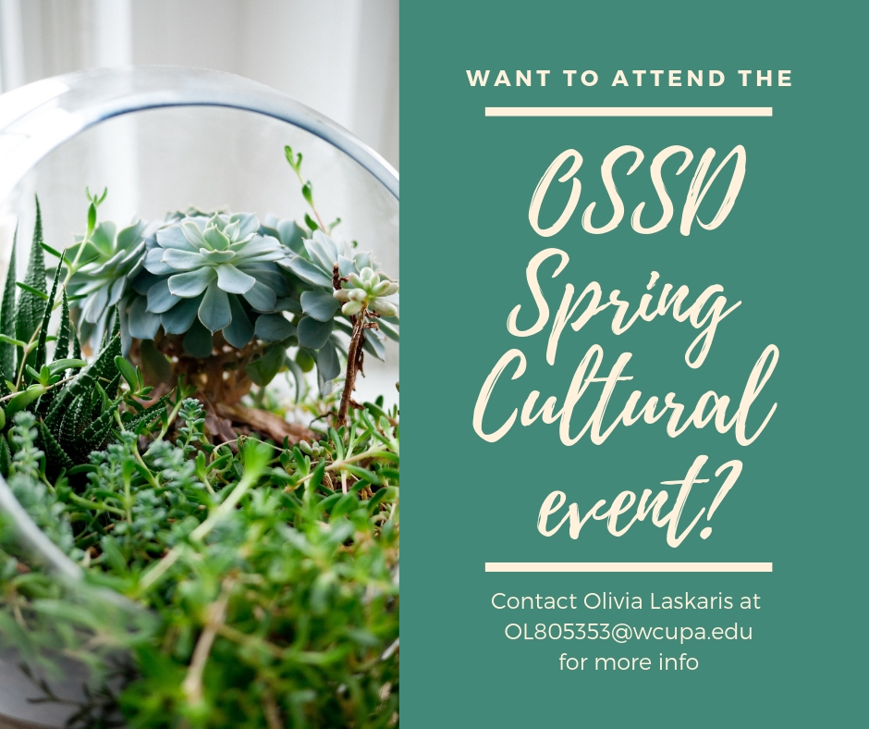

# Proctoring Center Spring 2019 Hours

|  |  |  |
| --- | --- | --- |
| **Day** | **Open** | **Close** |
| Monday | 8:00AM | 4:00PM |
| Tuesday | 8:00AM | 4:00PM |
| Wednesday | 8:00AM | 1:30PM |
| Thursday | 8:00AM | 4:00PM |
| Friday | 8:00AM | 4:00PM |

Meet the OSSD Staff!

Dr. Martin Patwell

**Director**

610-436-3217

Sharon Watson

**Assistant Director**

610-436-2775

Linda Laskaris

**Administrative Assistant**

610-436-2564

**Academic Coaches**

Michael Horvath

Amanda Martin

Kaitlin McCoale

Veronica Mattaboni

Olivia Laskaris

Liubov Patokina

**Writing Tutor**Veronica Mattaboni

**Math Tutor**

Julie Stoltzfus

**Mindfulness Instructors**

Kaitlin McCoale

**CART Captioner**

Susan Durkovic

**Technology Assistant**

Bryan Jones

