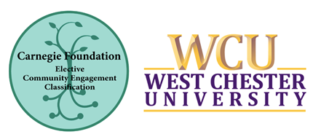
February 5, 2020 - WCU Recognized with the Carnegie Community Engagement Classification
We are pleased to announce that West Chester University was selected to receive the 2020 Carnegie Community Engagement Classification endorsement from the Carnegie Foundation for the Advancement of Teaching. We are one of 359 institutions to receive this elective classification, which involves data collection and documentation of important aspects of our institutional mission, identity, and commitment related to community engagement.
According to Paul LeMahieu, senior vice president at the Carnegie Foundation for the Advancement of Teaching, “The institutions we are recognizing… are doing extraordinary work in addressing their societal responsibilities in and through community engagement and service. In doing so, they bring scholarship, knowledge, and expertise to bear in the address of real challenges in our communal lives… They inspire us, even as they instruct us how to be our best selves in service to our communities.”
West Chester University was first classified in 2010 for a 10-year cycle. In 2018, we gathered a University-wide task force comprising staff and faculty from a variety of departments and disciplines to engage in a comprehensive self-study around our community engagement efforts. Thanks to the many members of the University community who contributed to this effort, especially the members of the core writing team who pulled the data together into a cohesive and comprehensive 84-page application:
Susan Argentieri, Center for Community Solutions Liaison & Graduate Center Event Manager
Kate Colyer, Former Assistant Director, Service-Learning & Volunteer Programs
Julie Dietrich, Executive Director for External Relations
Scott Heinrichs, Dean, College of Health Sciences
Sara Hinkle, Assistant Vice President, Student Affairs
Katie Solic, Associate Professor, Department of Literacy

Most of all, our faculty, staff, students (and former students) who are on the front line of our community engagement work are responsible for our successes in this area. Our gratitude goes to you, without whom we could not have achieved this milestone.

We look forward to the next steps of this work, as we use the data from the self-study to advance our institutional strategic priorities, inform our Middle States work and other accreditation needs, and enhance our efforts around community engagement.

