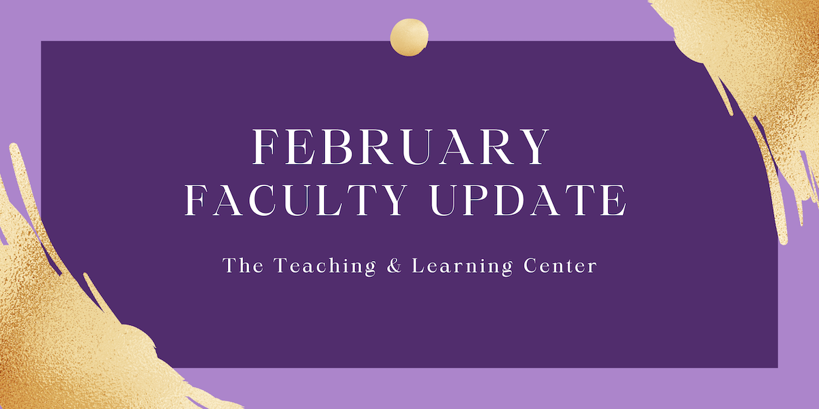

Open Initiatives

Padlet Pilot Program
The Teaching & Learning Center is excited to offer the Padlet Pilot Program again during the Spring 2024 semester! Padlet is an online visual board that can be used to organize and share content. It’s a great tool for facilitating both collaborative and individual activities and projects. The Teaching & Learning Center has procured a trial license, complete with D2L Integration.

Registration for the Padlet Pilot Program is open through Friday, February 9. To learn more, please visit the Padlet Pilot Program page on our website.

Pathways to Teaching Excellence
The Teaching & Learning Center is excited to offer the Padlet Pilot Program again during the Spring 2024 semester! Padlet is an online visual board that can be used to organize and share content. It’s a great tool for facilitating both collaborative and individual activities. It is currently available through a trial license that includes D2L Integration.
Registration for the Padlet Pilot Program is open through Friday, February 9. To learn more, please visit the Padlet Pilot Program page on our website.

CELT Professional Development Award
CELT is inviting proposals for its annual professional development award of up to $2,000 to advance improved student learning as part of WCU’s strategic plan. All tenured, tenure track, and regular part time faculty are eligible to apply. Proposals are due Friday, March 1.

Full guidelines, as well as a link to the application portal, can be found in the CELT Professional Development Funds Program Overview. Address any questions to CELT co-chairs Sandy Sarcona (asarcona@wcupa.edu) and Dawn Patterson (dpatterson@wcupa.edu).

Upcoming Events & Workshops

RECAP: Call for Proposals
We are thrilled to announce the Call for Proposals for the 29th Annual RECAP Conference on Thursday, May 16, 2024! The conference will be a gathering of forward-thinking educators, technologists, and innovators in higher education, hosted by Information Services & Technology in partnership with the TLC.
We invite you to be a part of this dynamic conference by submitting your proposal and joining us this May! Submissions are due by Monday, February 12, and notifications of acceptance will be sent by Friday, March 8.
- Submission Guidelines
- Proposal Submission Form

Generative AI Webinar on Sustainability
On Wednesday, February 14 from 12:00 to 12:50 in Sykes 255 A/B and on Zoom, a team from the Teaching & Learning Center will present on generative AI and sustainability as part of the Sustainability Research and Practice Seminar series hosted by the Sustainability Council. This is a continuation of the TLC webinar series from this fall on Generative AI. Please join us in Sykes or on Zoom; there is no need to register for this event.

Registration Open: Teaching Strides
Teaching Strides will return in Spring 2024. To better accommodate busy schedules, we are asking those interested in participating to sign up, and then we will work to find a common time for our weekly walk. Walks will begin in March.

Program Updates

Technology Roundup – Spring 2024
Check out the first edition of the Technology Roundup! This feature will be released on the TLC blog each Spring and Fall Semester with the purpose of keeping our WCU teaching and learning community informed on the latest instructional technologies.

New eTextbook: Python Programming Made Simple
Congratulations to Afrand Agah, Professor of Computer Science and participant in the Teaching & Learning Center’s eTextbook Initiative, for completing her new electronic textbook, Python Programming Made Simple. Dr. Agah’s book, which replaces a $95 commercial textbook, will be provided to WCU students for free and used in CSC 141 – Computer Science I starting in Spring 2024. To learn more, check out our blog!

New Navigating Digital Learning Tutorial on Generative AI
Introduction to Generative Artificial Intelligence is a new tutorial for students available now as part of Navigating Digital Learning. The tutorial overviews generative artificial intelligence including benefits, pitfalls, and how these types of tools might be used by students at West Chester University. All NDL tutorials provide users with a certificate of completion once the tutorial task is complete.

Online Faculty Development Program
Need to earn or renew your CAPC distance education credential? Faculty can now self-enroll into the OFD program’s D2L site using the Discover feature! Start working whenever it fits your schedule.

Stay Connected

ODLI on Air Podcast
Did you get a chance to hear from President Fiorentino on our latest episode “40 Years of WCU with President Fiorentino”?
On Valentine's Day, share some podcast love by listening to Dr. Uehling and Dr. Severino as they discuss what it was like being new tenure-track faculty teaching in their first semester.

Connect with Us
The Teaching and Learning Center is far more than just a newsletter! Our website hosts a variety of teaching resources and our full Event Calendar. To get in touch, feel free to send us an email, or stop by our drop-in hours to speak live with one of our designers.

