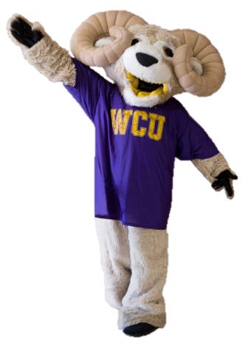

We’ve Heard Your Voice… And Are Taking Action!

Thank you for your feedback in taking the Faculty Survey of Student Engagement (FSSE) to tell us about your WCU experience. Let your voice be heard in 2014, complete the FSSE!

We answered:

* Direct your students to the Career Development Center which offers 45-minute in-person mock interviews and purchased Interview Stream software <https://wcupa.interviewstream.com/default.aspx> to let them perfect their interview presentation skills using a laptop and web cam.
* Do you know about the Ram Career Network? This database through the Career Development Center gives direct feedback on EVERY students’ first resume uploaded into the system.

<http://www.wcupa.edu/_SERVICES/STU.CAR/NewCSMEmployerFAQ.asp>

You said: Over 90% faculty indicated that discussing career interests is an important component of being an advisor.

We answered: International program offerings have increased by over 70% since last academic year. To learn how you can contribute to this increase contact: [jconradi@wcupa.edu](file:///C:\Users\75SHEINERICH\Desktop\jconradi@wcupa.edu)

You said: 31% of first year students indicated they plan to participate in a study abroad program.