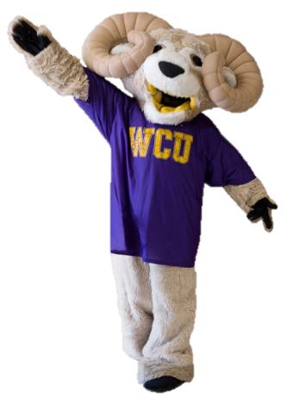

Thank you for your feedback in taking the Faculty Survey of Student Engagement (FSSE) to tell us about your WCU experience. Let your voice be heard in 2014, complete the FSSE!

We answered: The TLA Center and Office of Distance Education is providing lunch on 2/19/14 to discuss how to implement this tool to help both your program and students. Email [agrinwis@wcupa.edu](mailto:agrinwis@wcupa.edu) to reserve your spot!

You said: Over 73% of faculty indicated they have never used E-Portfolio.

We answered: The LARC provided Diversity Training 411 for faculty and staff this past fall to encourage diversity awareness on campus. Contact Marcie Cohen (610-436-2535).

You said: It was important for students to have discussions with individuals with different racial or ethnic , religious, economic, and political views other than your own.

We’ve Heard Your Voice… And Are Taking Action!