WCU Master of Science in Applied Statistics - Non-Thesis option
Graduate Advising Sheet. (33-34 credits)

Student Name: _____________________WCU ID # _________________ Semester accepted ______________

Core Curriculum (24 credit hours) Semester Year Grade
STA 503 (1) Introduction to R Programming ________ ____ _____
STA 505 (3) Mathematical Statistics 1 or ________ ____ _____
STA 504 (4) Mathematical Statistics w/Calculus Review ________ ____ _____
STA 506 (3) Mathematical Statistics II ________ ____ _____
STA 507 (3) Introduction to Categorical Data Analysis ________ ____ _____
STA 511 (3) Introduction to Statistical Computing
and Data Management ________ ____ _____
STA 512 (4) Principles of Experimental Analysis ________ ____ _____
STA 513 (4) Intermediate Linear Models ________ ____ _____
STA 514 (3) Modern Experimental Design ________ ____ _____

Internship in Applied Statistics (Optional) Semester Year Grade

STA 601 Internship ________ ____ _____

Applied Statistics Elective (6-9 credit hours)

Course Semester Year Grade
1. Elective __________________________________________________ ____________ ______ _______
2 Elective __________________________________________________ ________ ____ _____
3. Elective if Internship not elected______________________ ________ ____ _____

Choose from:
STA 531 Topics in Applied Statistics
STA 532 Survival Analysis
STA 533 Longitudinal Data Analysis
STA 534 Time Series
STA 535 Multivariate Data Analysis
STA 536 Data Mining
STA 537 Advanced Statistical Programming Using SAS
STA 538 Statistical Programming Using R
STA 539 Applied Bayesian Methods
STA 540 Statistical Consulting
STA 541 Categorical Data Analysis II
STA 542 Observational Studies
STA 543 Statistical Methods in Business and Finance
STA 544 Marketing Analytics
STA 545 Statistical Issues in Clinical Trials
STA 551 Foundations of Data Science
STA 552 Applied Statistical Machine Learning
STA 553 Data Visualization and Infographics

WCU Master of Science in Applied Statistics - Thesis option
Graduate Advising Sheet. (33-34 credits)

Student Name: ________________________ WCU ID # _________________Semester accepted _________
Core Curriculum (24 credit hours) Semester Year Grade
STA 503 (1) Introduction to R Programming ________ _____ ______
STA 505 (3) Mathematical Statistics 1 or ________ _____ ______
STA 504 (4) Mathematical Statistics w/Calculus Review ________ _____ ______
STA 506 (3) Mathematical Statistics II ________ _____ ______
STA 507 (3) Introduction to Categorical Data Analysis ________ _____ ______
STA 511 (3) Introduction to Statistical Computing
and Data Management ________ _____ ______
STA 512 (4) Principles of Experimental Analysis ________ _____ ______
STA 513 (4) Intermediate Linear Models ________ _____ ______
STA 514 (3) Modern Experimental Design ________ _____ ______

Thesis in Applied Statistics Semester Year Grade
STA 609 (3-6) Thesis I ________ _____ ______
STA 610 (3-6) Thesis II ________ _____ ______

Internship in Applied Statistics (Optional) Semester Year Grade
STA 601 Internship ________ _____ ______

Applied Statistics Elective (3-6 credit hours)
Course Semester Year Grade
1. Elective_______________________________________________________ ________ _____ ______
2. Elective if Internship not elected_______________________________ ________ _____ ______

Choose from:
STA 531 Topics in Applied Statistics
STA 532 Survival Analysis
STA 533 Longitudinal Data Analysis
STA 534 Time Series
STA 535 Multivariate Data Analysis
STA 536 Data Mining
STA 537 Advanced Statistical Programming Using SAS
STA 538 Statistical Programming Using R
STA 539 Applied Bayesian Methods
STA 540 Statistical Consulting
STA 541 Categorical Data Analysis II
STA 542 Observational Studies
STA 543 Statistical Methods in Business and Finance
STA 544 Marketing Analytics
STA 545 Statistical Issues in Clinical Trials
STA 551 Foundations of Data Science
STA 552 Applied Statistical Machine Learning
STA 553 Data Visualization and Infographics

The concentration in Biostatistics and Bioinformatics differs from the general Applied Statistics degrees shown above in requiring specific elective courses relevant to Biostatistics and/or Bioinformatics. These electives include: STA 532, STA 533, STA 537, STA 539, STA 540, STA 541, STA 542, STA 601, or STA 609. Other STA electives may be substituted with permission of the Program Director. The concentration in Business and Marketing Analytics differs from the general Applied Statistics degrees shown above in requiring specific elective courses relevant to Business and Marketing Analytics. These electives include : STA 534, STA 535, STA 536, STA 537, STA 538, STA 543, STA 544, STA 601, or STA 609. Other STA electives may be substituted with permission of the Program Director. The concentration in Data Science differs from the general Applied Statistics degrees shown above in requiring STA 551 as one of the elective courses. In addition, the two other electives selected by a student in the Data Science concentration must be selected from the following list: STA 534, STA 536, STA 537, STA 543, STA 544, STA 552, STA552, STA601, or STA609. Other STA electives or CSC 545 mat be substituted with permission of the Program Director. Specific advising sheets are shown below.

¹ | 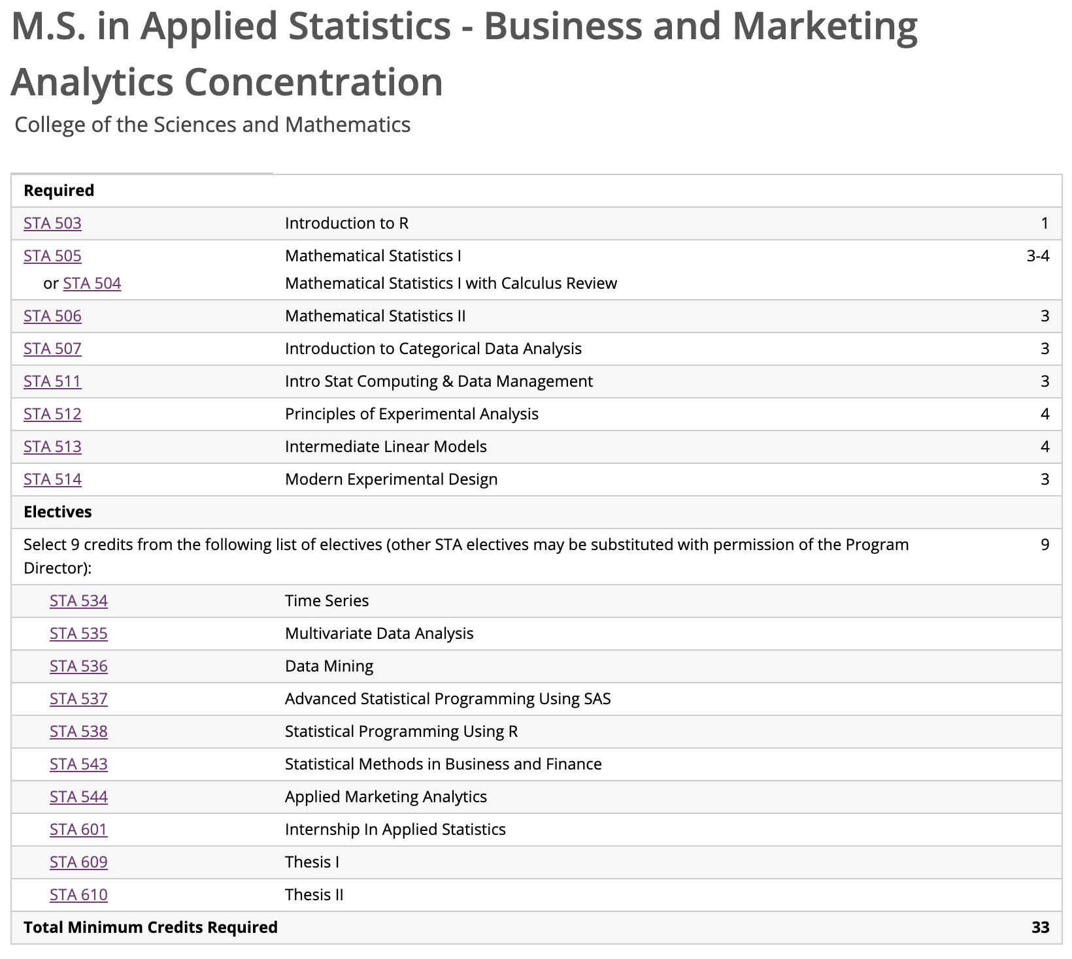

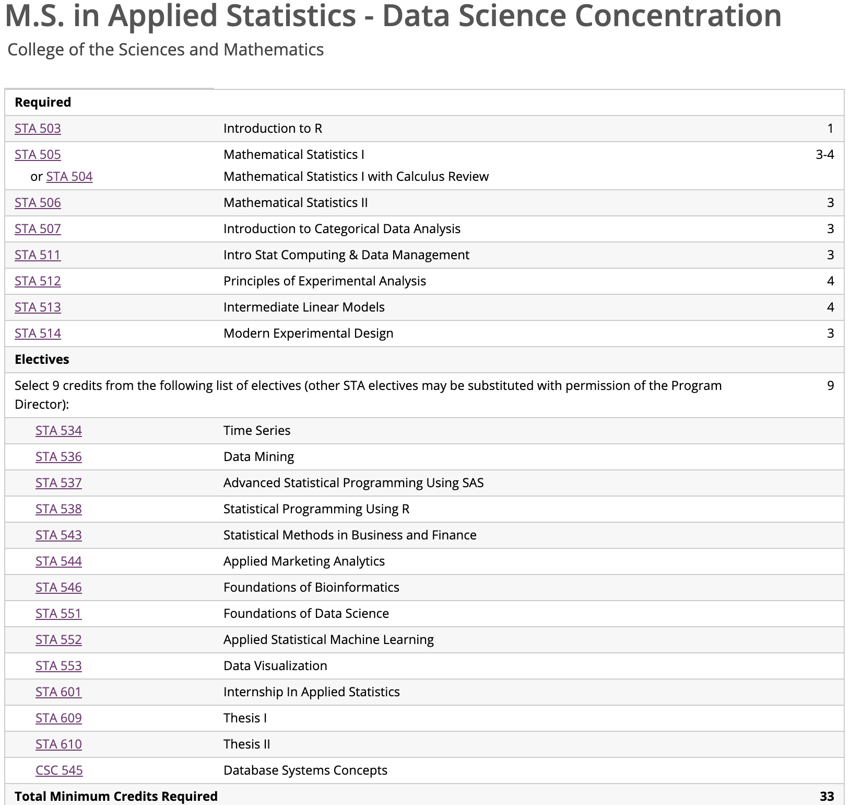

M.S. in Applied Statistics - Biostatistics and Bioinformatics Concentration
College of the Sciences and Mathematics
Code | Title | Credits
Required
STA 503 | Introduction to R | 1
STA 505 | Mathematical Statistics I | 3-4
or STA 504 | Mathematical Statistics I with Calculus Review
STA 506 | Mathematical Statistics II | 3
STA 507 | Introduction to Categorical Data Analysis | 3
STA 511 | Intro Stat Computing & Data Management | 3
STA 512 | Principles of Experimental Analysis | 4
STA 513 | Intermediate Linear Models | 4
STA 514 | Modern Experimental Design | 3
Electives
Select 9 credits from the following list of electives (other STA electives may be substituted with permission of the Program Director): |  | 9
STA 532 | Survival Analysis
STA 533 | Longitudinal Data Analysis
STA 537 | Advanced Statistical Programming Using SAS
STA 539 | Applied Bayesian Methods
STA 540 | Statistical Consulting
STA 541 | Categorical Data Analysis II
STA 542 | Statistical Methods for Observational Studies
STA 545 | Statistical Design and Analysis of Clinical Trials
STA 546 | Foundations of Bioinformatics
STA 601 | Internship In Applied Statistics
STA 609 | Thesis I
STA 610 | Thesis II
Total Minimum Credits Required |  | 33
Course List

Post-Master's Certificate of Advanced Study in Applied Statistics

Students must take four classes from the following list ¹
STA 531 | Topics In Applied Statistics
STA 532 | Survival Analysis
STA 533 | Longitudinal Data Analysis
STA 534 | Time Series
STA 535 | Multivariate Data Analysis
STA 536 | Data Mining
STA 537 | Advanced Statistical Programming Using SAS
STA 538 | Statistical Programming Using R
STA 539 | Applied Bayesian Methods
STA 540 | Statistical Consulting
STA 541 | Categorical Data Analysis II
STA 542 | Statistical Methods for Observational Studies
STA 543 | Statistical Methods in Business and Finance
STA 544 | Applied Marketing Analytics
STA 545 Statistical Issues in Clinical Trials
STA 551 Foundations of Data Science
STA 552 Applied Statistical Machine Learning
STA 553 Data Visualization and Infographics

¹ Selected courses must be different than courses already taken as part of preexisting Master's degree. Additional courses may be selected, or exceptions made, at the discretion of the Program Director.

