Rhythmic Concepts Masterclass Dave Allen

Triplet Groupings:
Example 1: Twos (using 3rds)
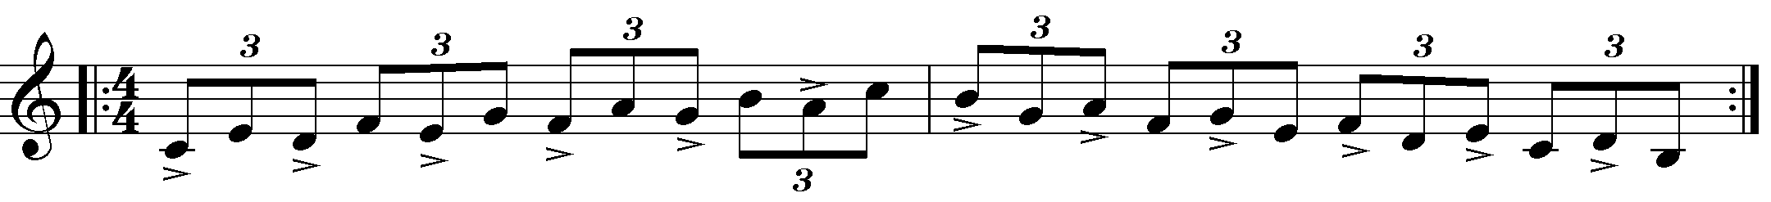
Ex 2. Fours (Using 7th chords)
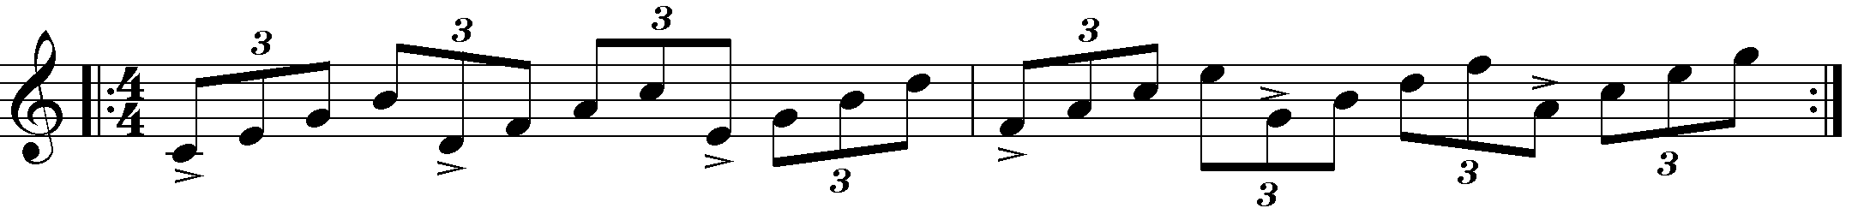

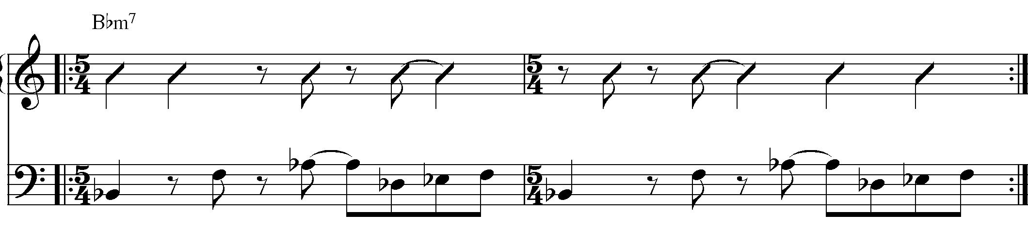

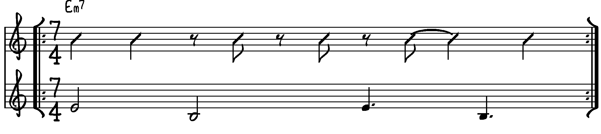
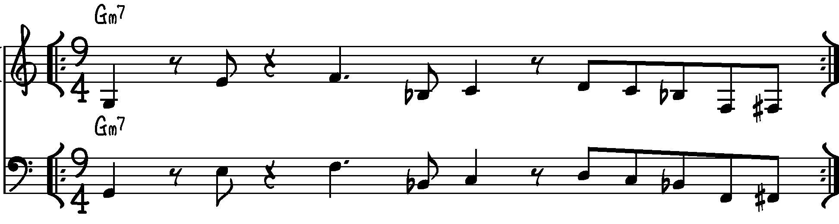

Pulsion (A section only) Dave Allen

