Student Reminders
The following guide contains step-by-step instructions and screenshots for connecting your device to Proctorio for the first time.
Reminder | Image
When you first click on a Proctorio quiz in D2L, you may get the following warning. It is safe to click allow- and you must click it to continue your quiz. | 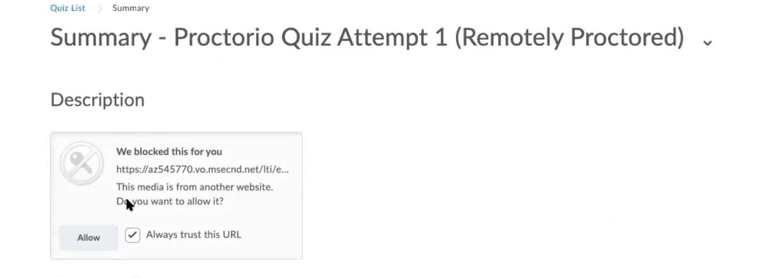
If you have not used Proctorio before, you will get the following prompt to download the extension. Click on the “Click Here” prompt. | 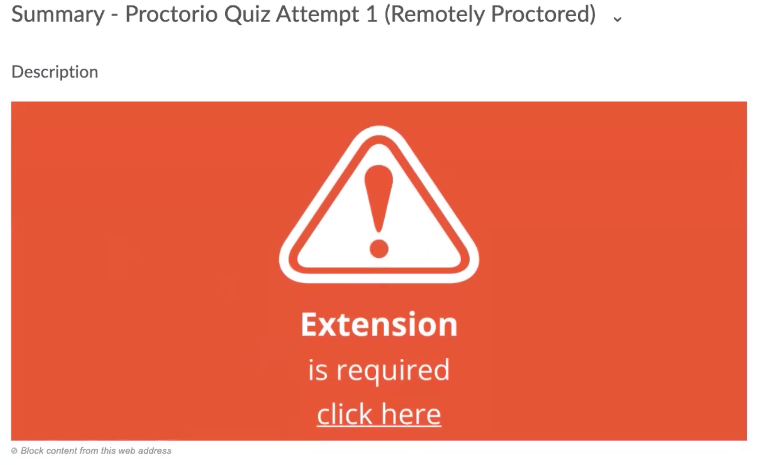
You will be automatically directed to the directions for installing Proctorio. Again, choose “Click Here.” | 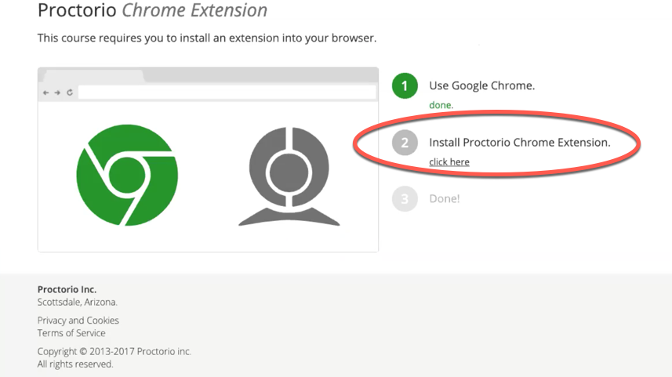
You will automatically be directed to the Chrome extension store. Choose to Add to Chrome. | 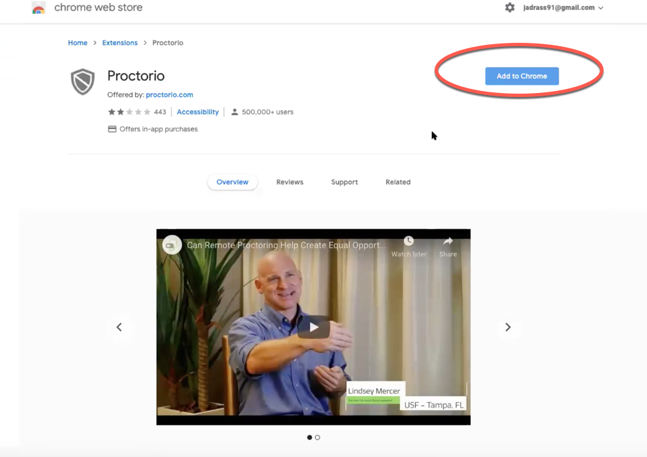
You may be asked to open System Preferences and give Proctorio access to your microphone, webcam, and/or screen-capture. | 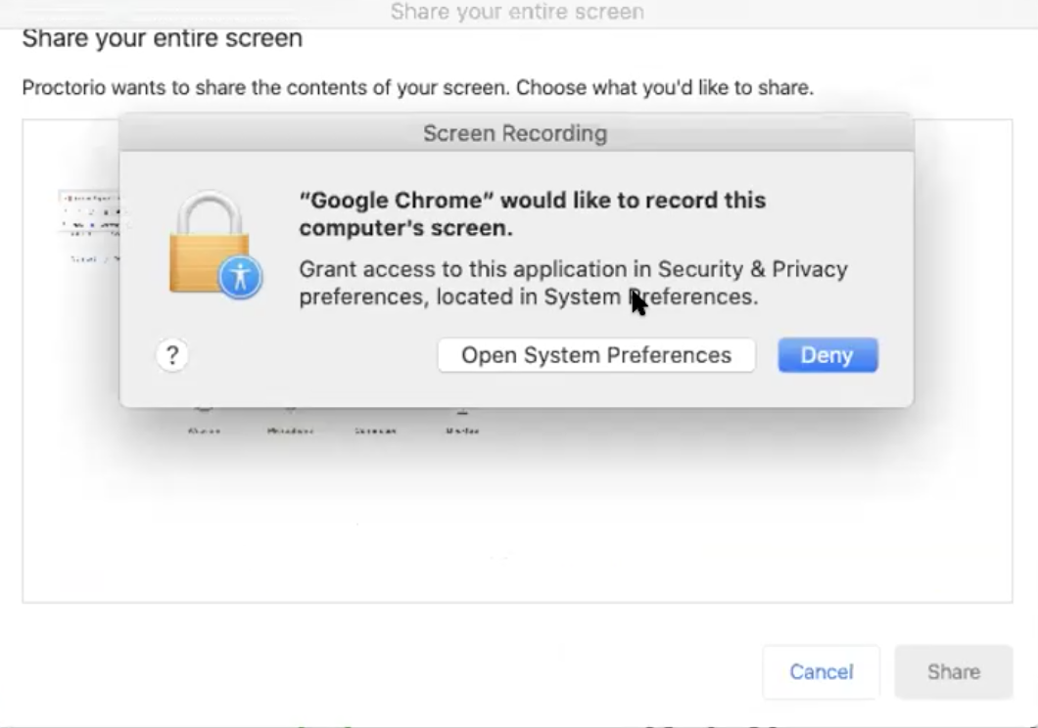  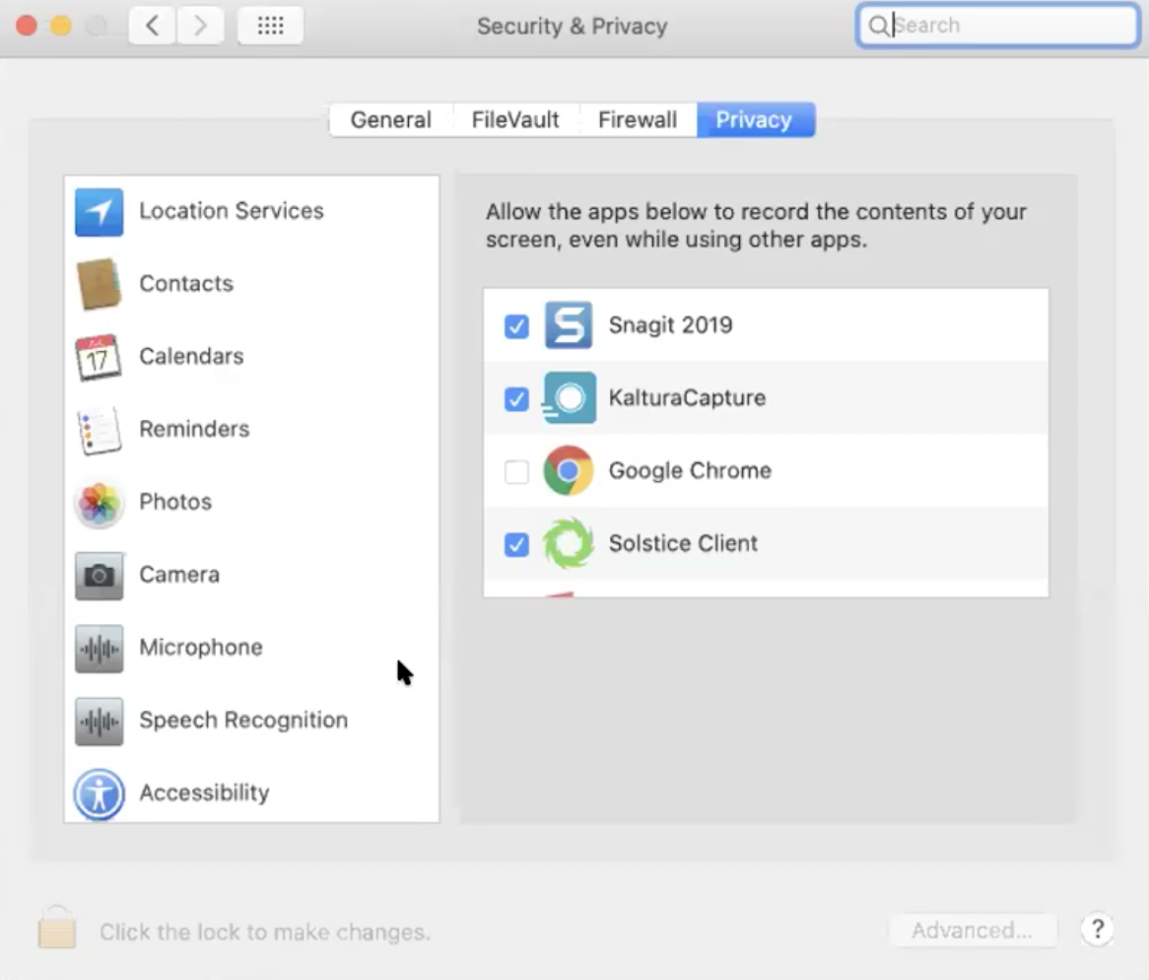  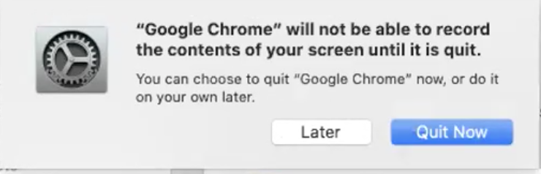
The checklist is now done and you can return to D2L. If you have already installed Proctorio previously, you will begin at this step.
You will see a list of proctoring requirements, as put forth by your professor. | 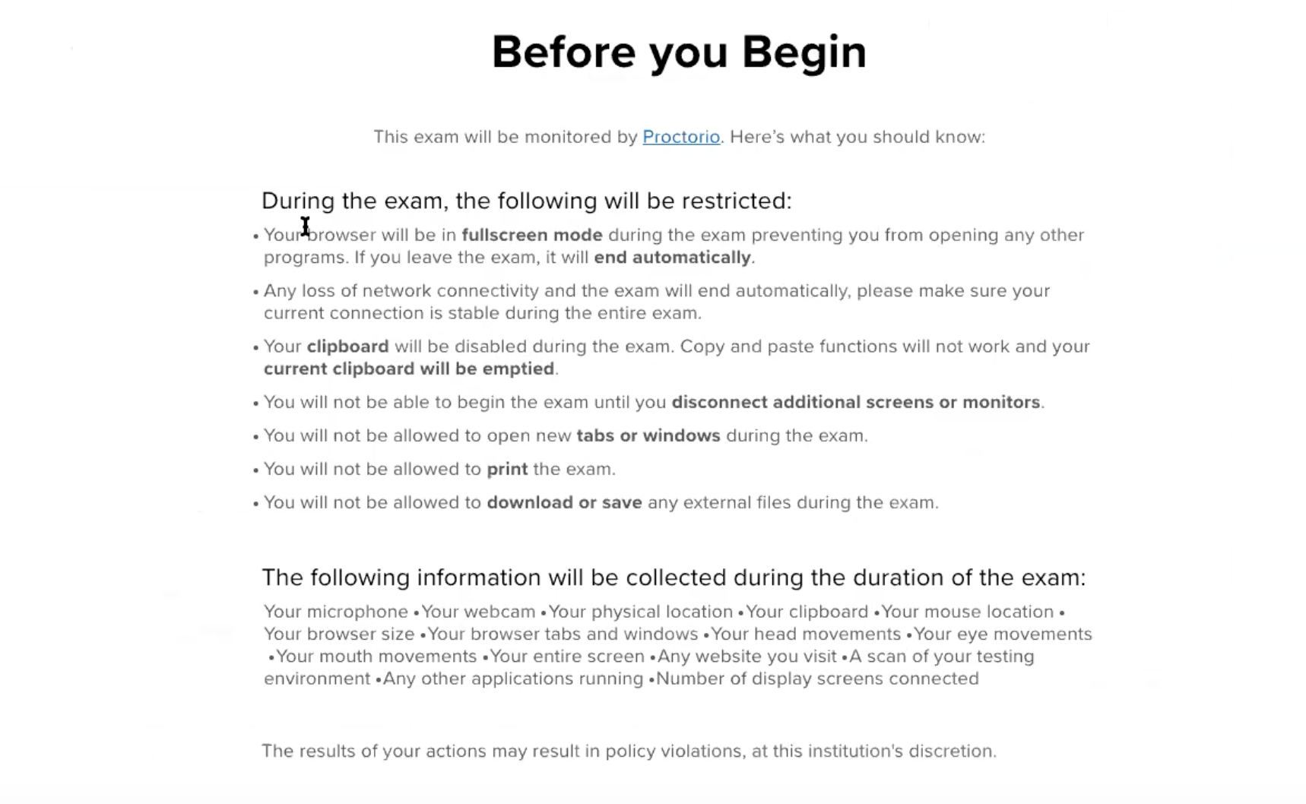
If your professor has set any requirements that you are currently violating (for example, not allowing multiple tabs to be open), you will be prompted to remedy them. | 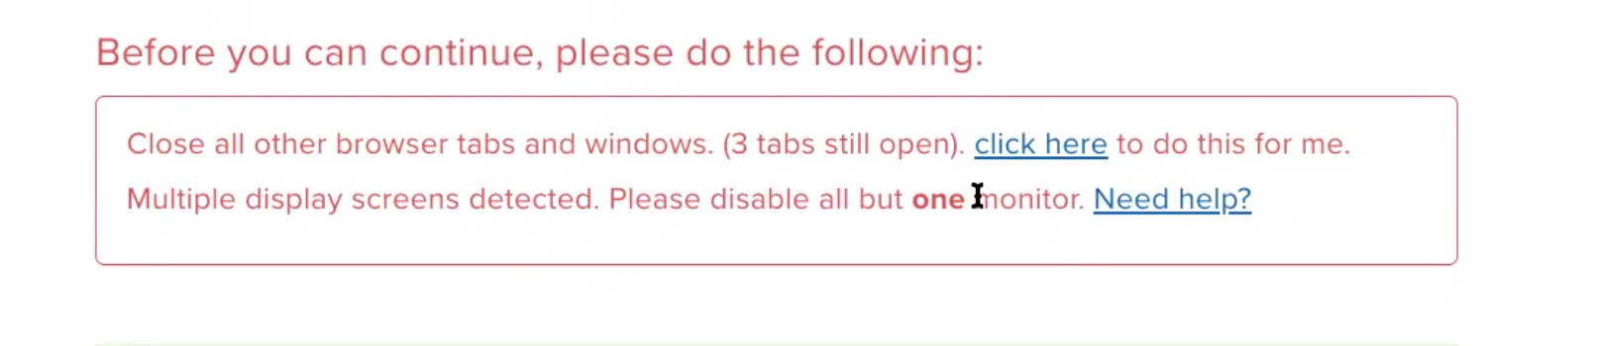
If you haven’t shut your computer down in awhile, or you’re running on battery power, Proctorio may send you a series of warnings. Failing to comply with these warnings will NOT inhibit your ability to continue with the exam. | 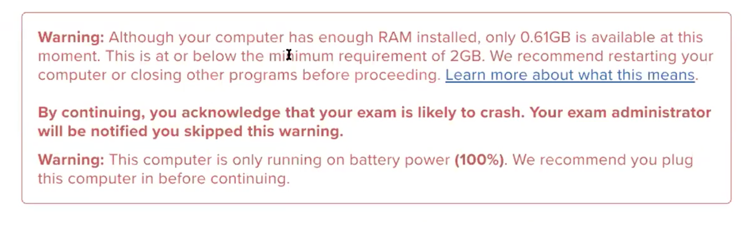
Proctorio will run a diagnostic test of your computer. | 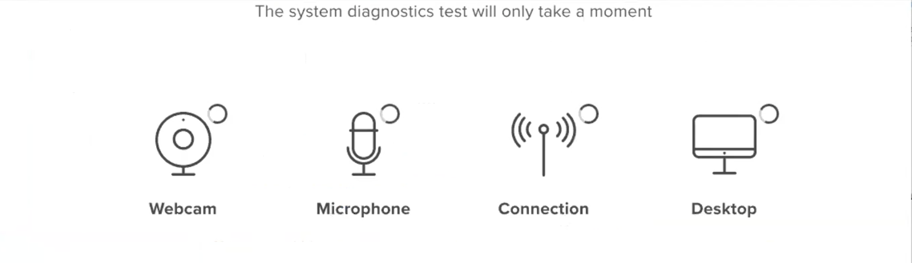
Depending on the requirements set forth by your professor, you may need to share your screen, take a picture of your WCU ID, or scan your room.
That’s it! You’re ready to begin. Good luck!

