When Instructor is Setting Up Exam in Examity:
- Exam MUST have a password attached. Professor should NOT disseminate this password to students via any methods; rather this password is a way for Examity software to communicate to D2L software securely.
- When prompted for the exam link, all instructions should enter d2l.wcupa.edu.

When Student is Scheduling/ Ready to Take Exam:
STUDENTS MUST USE CHROME TO TAKE EXAMS. Students may NOT use Chromebooks.
The benefit of automated standard and automated premium proctoring is that students do NOT need to pre-schedule exam slots. Students can schedule and take the exam all in one sitting; however, they MUST schedule a time (even for same-sitting exam slots).
STEP | SCREENSHOT | DESCRIPTION
 | 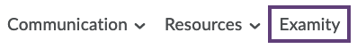 | Navigate to the course in D2L and select “Examity” in the top navigation bar.
 | 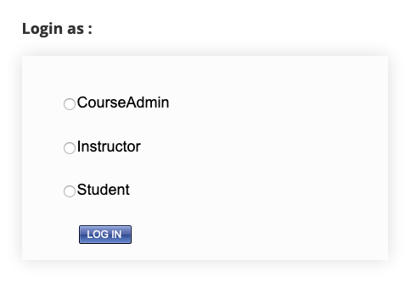 | Log in as “Student.” (NOTE: Students may not see this screen as they only have one log-in option.)
 | 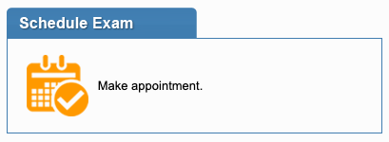 | If you’re a first-time Examity user, create a profile as prompted. If you have used Examity before, select “Schedule Exam”.
 | 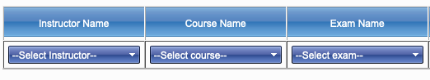 | Select your instructor, class, and exam from the dropdowns.
 | 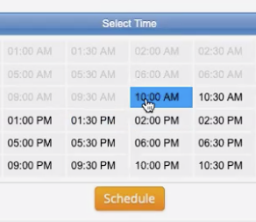 | Even for same-sitting exams, select a time (usually the next available time slot) and select “Schedule”.
 | 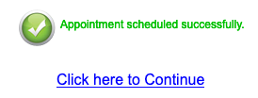 | After reviewing the rules, select “Click here to Continue”.
 | 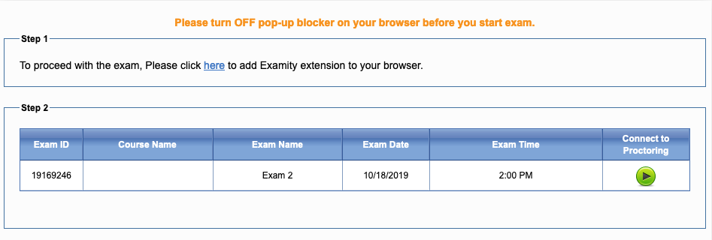 | Ensure that your pop-up blocker has been turned off.  If you’re a first-time Examity user, add the Examity extension to your browser by following the prompt on-screen.  Select the green triangle button “Connect to Proctoring”
 | 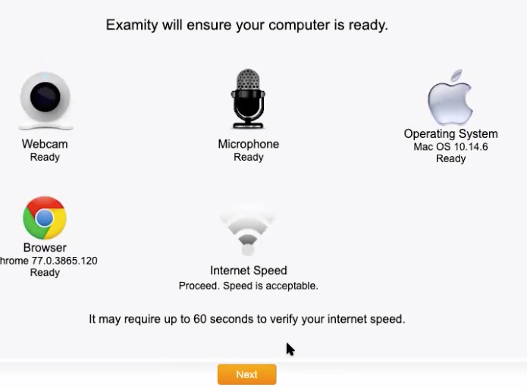 | Examity will ensure your computer is ready by testing the webcam, microphone, browser, and internet speed. Select “Next” once everything is verified.
 | 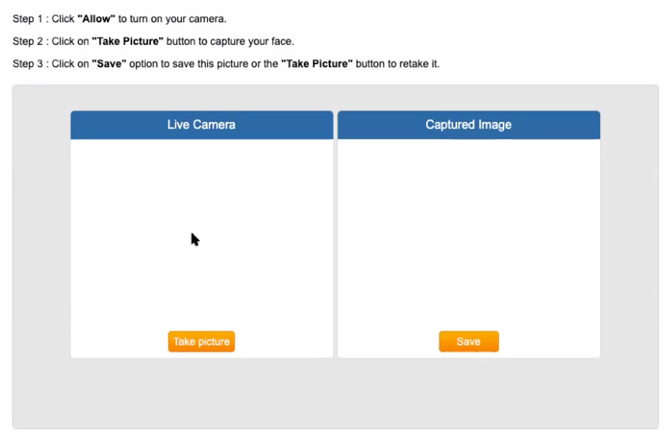 | The system will prompt you through various identification measures. Follow the steps on screen.  Answer the security question.
 | 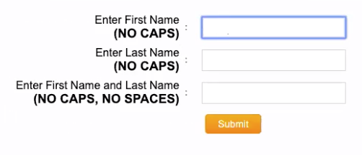 | Provide various biometric keystrokes by typing in your first name, last name, and first and last name.
 | 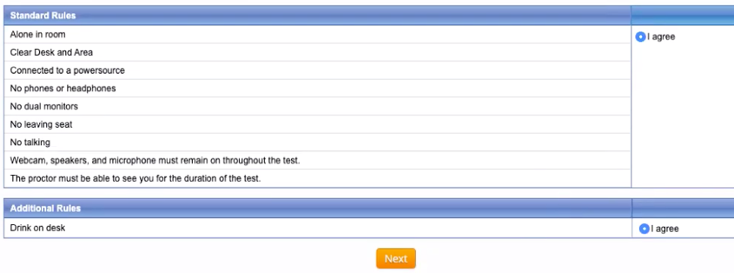 | Complete the user agreement by selecting “I agree” next to each statement.
 | 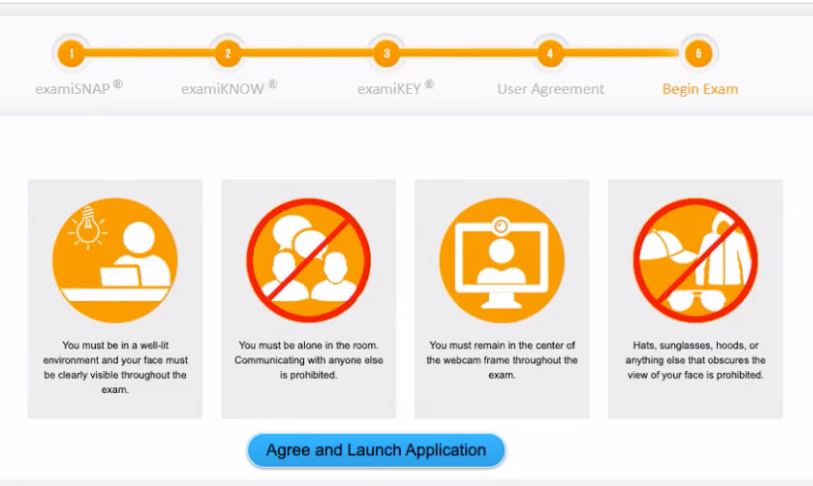 | Select “Agree and Launch Application”.  A pop-up will then appear prompting you to begin exam. This popup will remain open for the duration of the exam but can be minimized if it takes up too much of your screen.  The minimized pop-up will relocate to the side of your screen as a blue plus-mark box.
 | 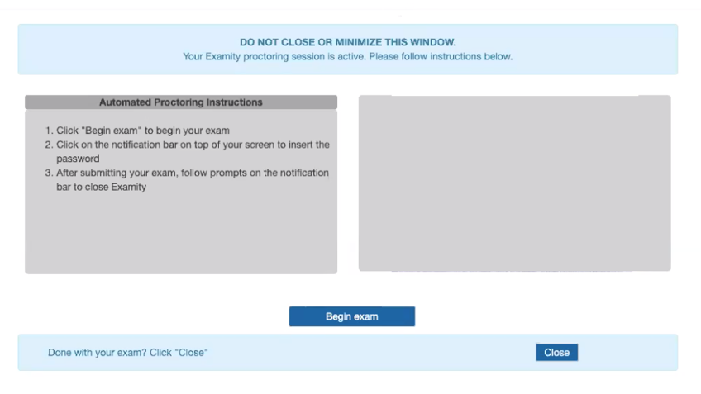 | Once you choose “Begin Exam” in the popup window, you will be directed back to d2l.wcupa.edu. Navigate to your course.
 | 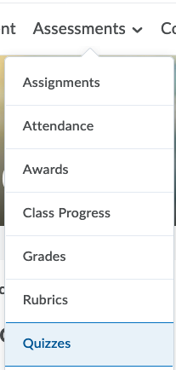 | Select “Assessments” in the top navigation bar and then “Quizzes”. Select the appropriate exam.
 | 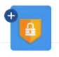 | If the exam password has not automatically populated, select the plus sign of the blue Examity box.
 | 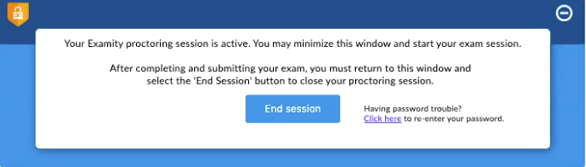 | Select “Click here to re-enter your password”. The exam password should then automatically populate and you can select “Start Quiz!”  You can select the minus sign to minimize the Examity box while taking your exam.  When you have completed your exam, select the plus sign again and select “End Session”.

Reminder that if you become stuck at any point during this tutorial, you can reach out to Examity directly at 855-392-6489 ext1 or via support@examity.com .

