Faculty Guidelines
Below is the process for making the Proctorio integration appear to faculty view in D2L. Remember you must be in Chrome when installing and when adding Proctorio settings to an assessment.
Step | Screenshot
- In your D2L course, click on the Course Admin tab (in your top NavBar.) | 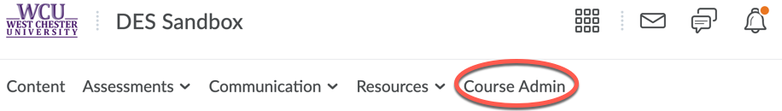
- Under Site Resources, select “External Learning Tools.” | 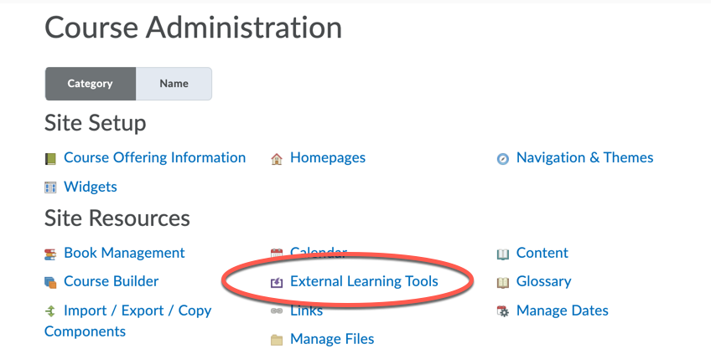
- Scroll down to confirm that “Secure Exam Proctor” is listed. This confirms that D2L Services has added the integration. Nothing to click here; just a confirmation that you can proceed to the next step.
- Return to the Content section of your D2L course. | 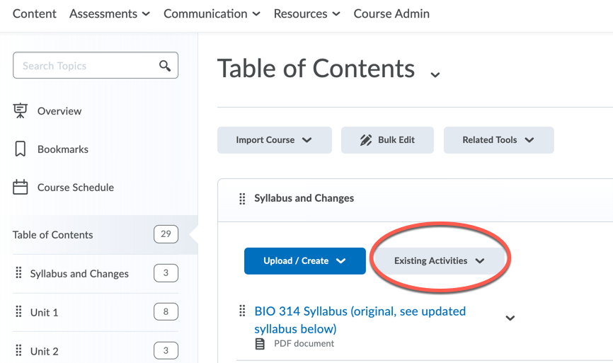
- Choose “Existing Activities” and locate “External Learning Tools.” Select “External Learning Tools.” | 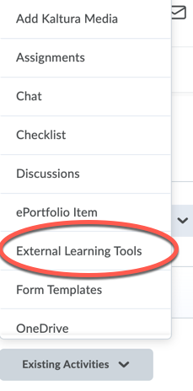
- This will bring you to the “Add Activity” box. Scroll down and select “Secure Exam Proctor.” (You are not just confirming location this time. You must actually click on “Secure Exam Proctor.” | 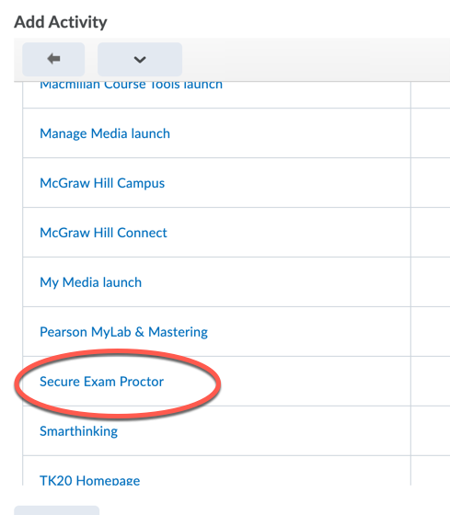
- D2L will automatically take you back to your content screen. You will now see “Secure Exam Proctor” listed in your content. Select it.  (*NOTE: If you are checking your steps on a course that previously had Proctorio connected, you may not see “Secure Exam Proctor” listed under content anymore. This is by design. You do NOT need to use the eye icon to hide Proctorio.) | 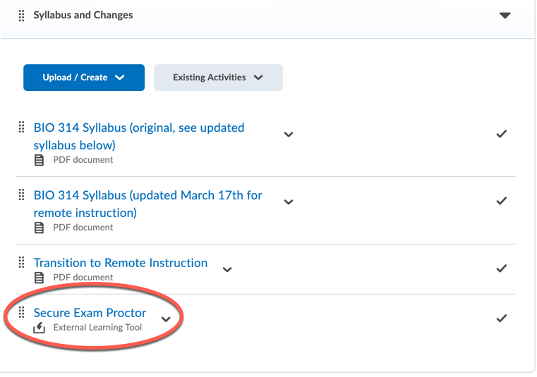
- If you have not installed the Proctorio Chrome extension, Proctorio will now direct you to the Chrome store. If you have already downloaded the extension, you will see a confirmation. | 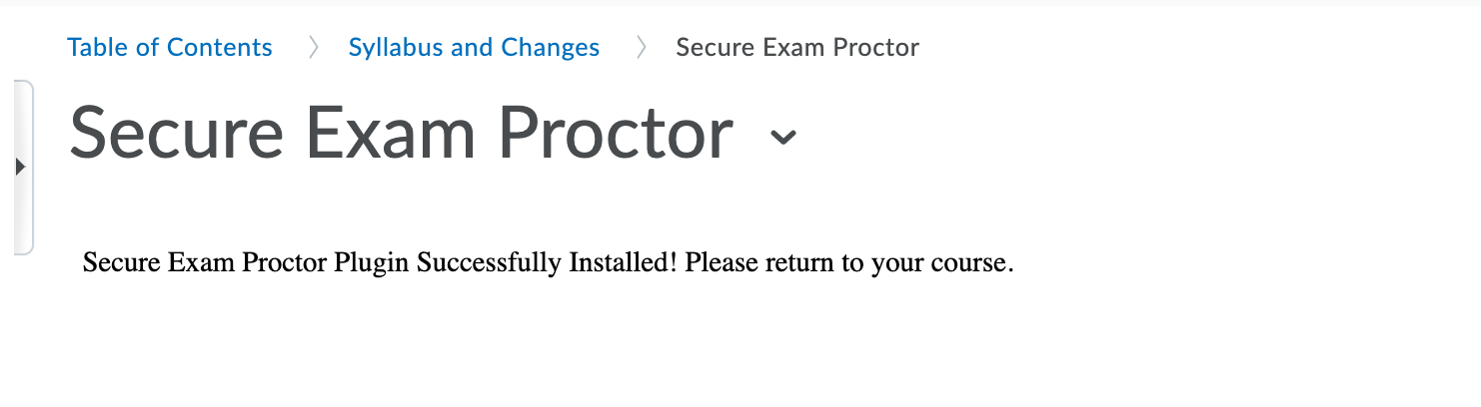
- You may need to access System Preferences to allow Chrome to have access to your microphone, webcam, and computer. | 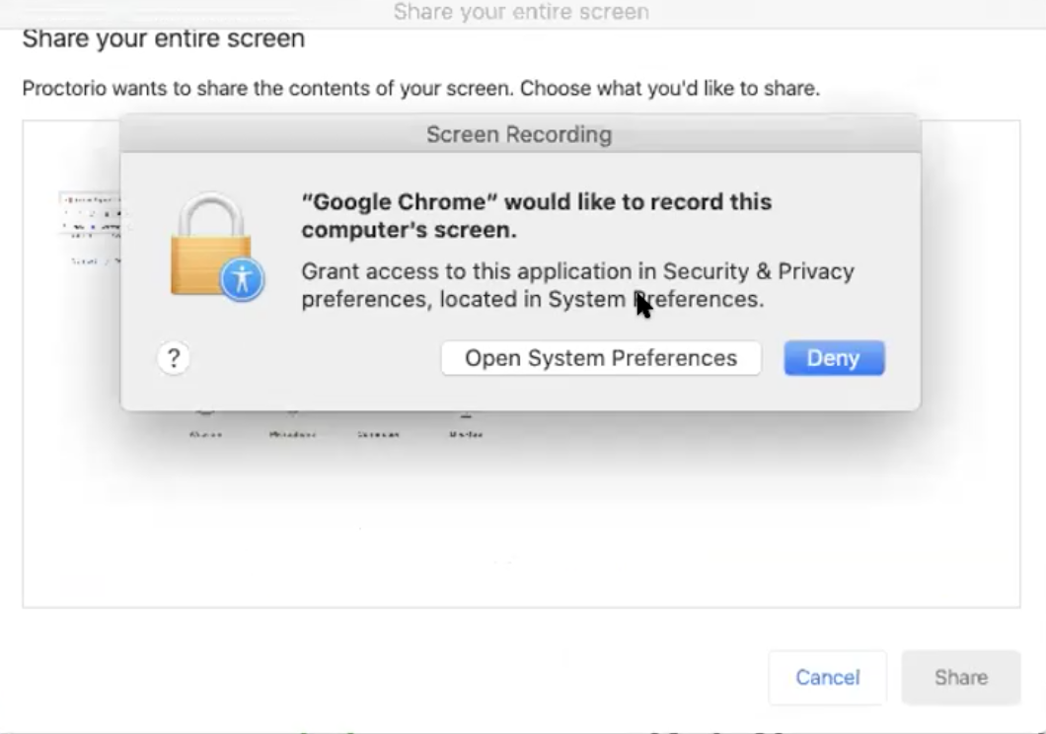  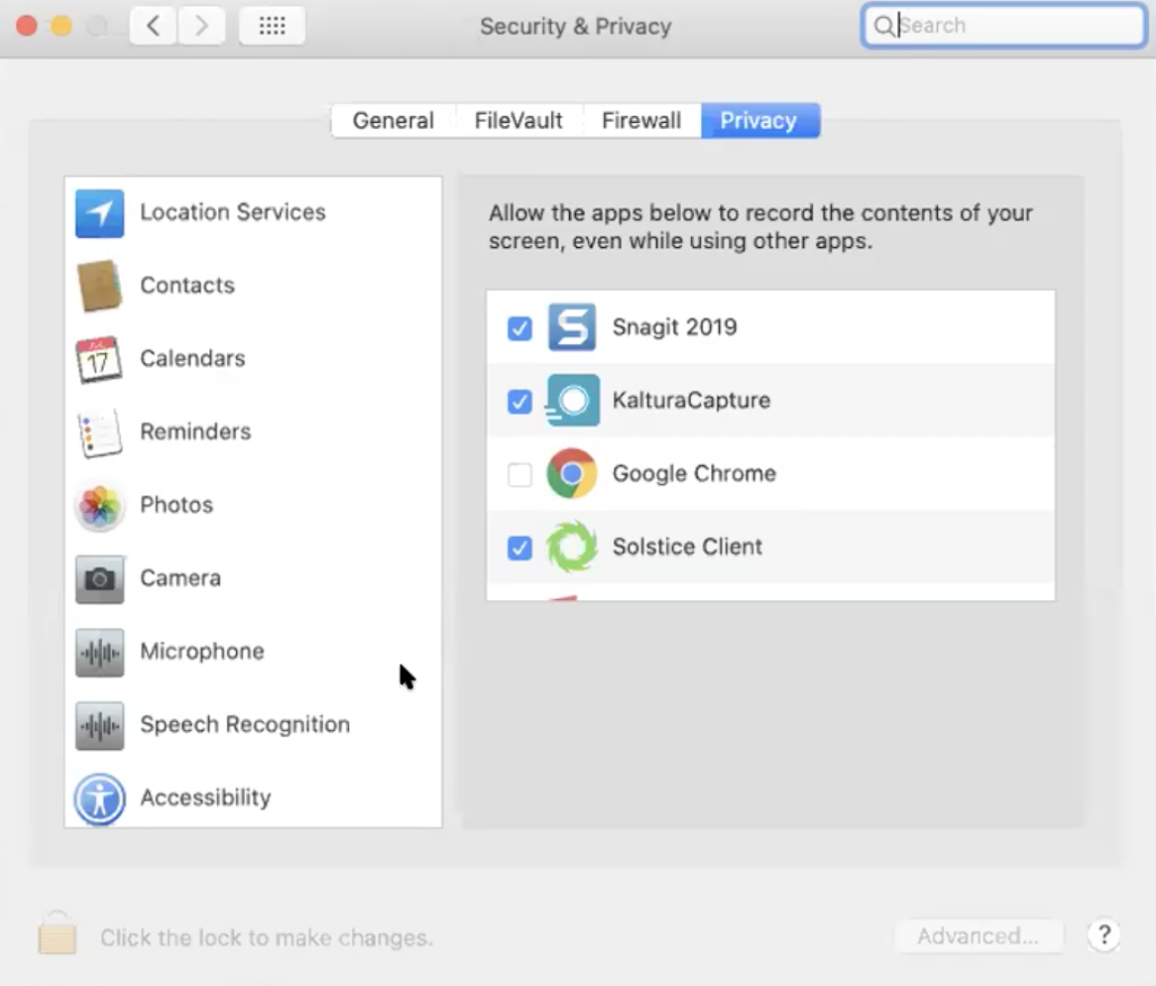  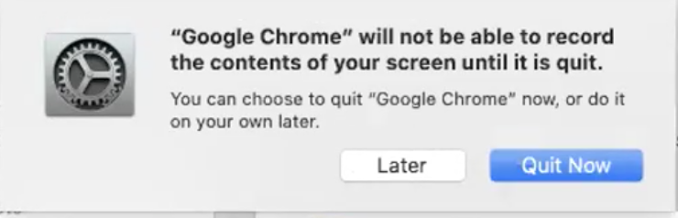
- The gray Proctorio shield now lives next to your web address bar. | 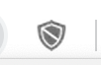
- Secure Exam Proctor now lives in your Content section. Please use the gray dots to drag “Secure Exam Proctor” to the top of your content for easy access should you need Proctorio help in the future.  (*Note- You will not see “Secure Exam Proctor” in your Content section from here on out. Proctorio automatically hides itself to keep students from inadvertently clicking on it. Please do NOT hide Proctorio using the D2L eye icon. Doing so will cause Proctorio to become inoperable.) | 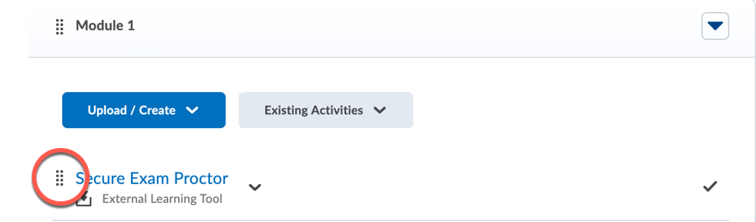
- Across the top navbar of your D2L course, select “Assessments” and “Quizzes.” You will now see that the option for “Proctorio Settings” appears with existing and new quizzes.  (*Note- If you would like to add Proctorio to an existing quiz that has already been attempted, you may need to duplicate the quiz for Proctorio to be function.) | 