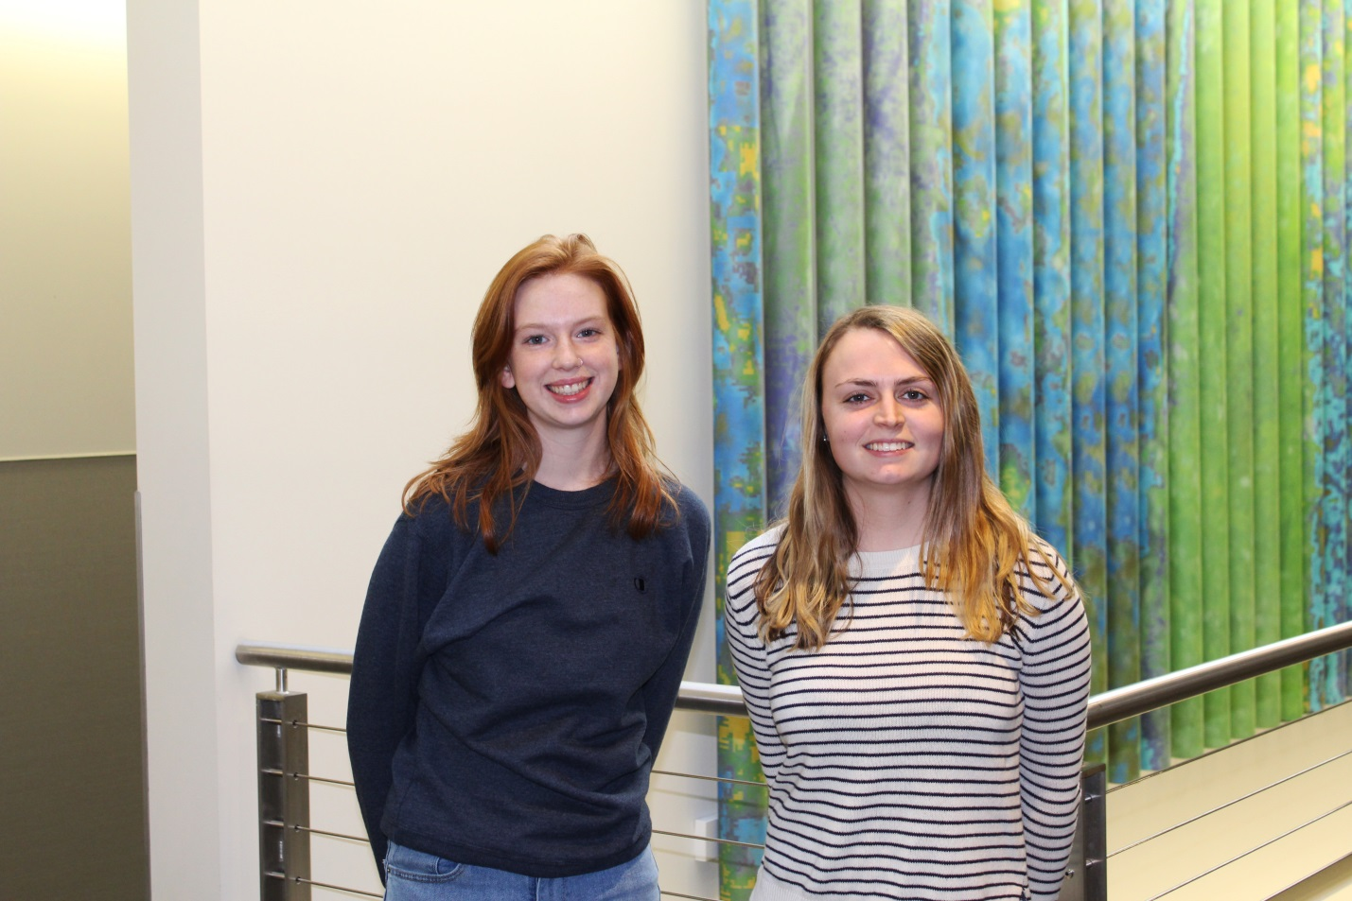
Grace McDonough & Caitlin Pedersen Awarded George Fasic Planning Scholarship
The 2017 George Fasic Planning Scholarship has been awarded to Grace McDonough and Caitlin Pedersen, both sophomores majoring in Urban and Environmental Planning. The George Fasic Planning Scholarship supports one or two undergraduate and/or graduate students studying planning, with a demonstrated interest in pursuing a career in planning or preparing for graduate study in planning.
McDonough’s passion for planning began in high school as she served as a Junior Borough Council Member in Christiana, Pa. It was in council meetings listening to discussions about waste water management and treatment, zoning, land-use planning, and ordinance writing that sparked her interest and desire to study planning.
Pedersen has plans to immediately pursue her master’s degree upon obtaining her bachelor’s degree from WCU. Growing up in the rural area of Lehigh County where farm land has been taken over by housing development and growing business, she has seen firsthand how important the role planning plays in land preservation and environmental protection.

