WEST CHESTER UNIVERSITY
GEORGE FASIC SCHOLARSHIP FUND
2016 RECIPIENTS
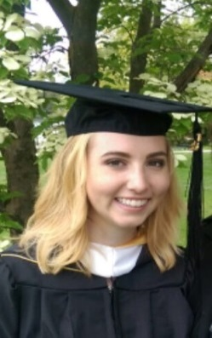 Katelyn Thompson, Lancaster
- Intern/Case File Reviewer at CWS Refugee Resettlement Agency –Lancaster, PA
- Millersville University 2016 graduate- BA Geography, geospatial applications, minor in International Studies
- Completed an undergraduate thesis on refugee sense of place in Lancaster, PA
- DVGA Outstanding Geography Student at Millersville University 2016
- WCU Writing Center Tutor/ Planning Graduate Assistantship with Dr. Ives Dewey
- Currently pursuing an MA in Geography and Certificates in GIS and Urban/Regional Planning from WCU
- Wants to become a certified planner by AICP
- Planning interests include zoning, land use, housing
- Potential MA Thesis - the effects of zoning, land use, in relation to sense of place/place attachment specifically in suburban communities
- Hobbies include refurbishing furniture with my dad, reading cookbooks, and collecting atlases

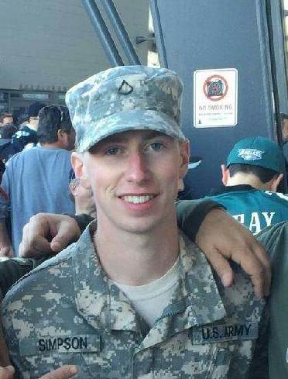 Richard Simpson, Glen Mills
- Bayard Rustin High School
- Army National Guard (2013-present), 19D Cavalry Scout, 11B Infantryman
- Currently pursuing a B.S. in Urban and Environmental Planning from WCU
- President of the Student Veterans Group (Past Vice-President & Secretary)
- Multiple charity donations and community involvement with the SVG
  - Toys for Tots
  - Care-packages to deployed troops
  - Canned food drives for the West Chester Food Cupboard
  - Adopt-a-block in West Chester Borough
- WCU Student Veterans Group Coalition Award (2)
- WCU Veterans Scholarship
- Would like a career with the government
- Enjoys hunting, riding motorcycles, Philadelphia Flyers, and hanging out with my dog

