WCU Entrepreneurship Club

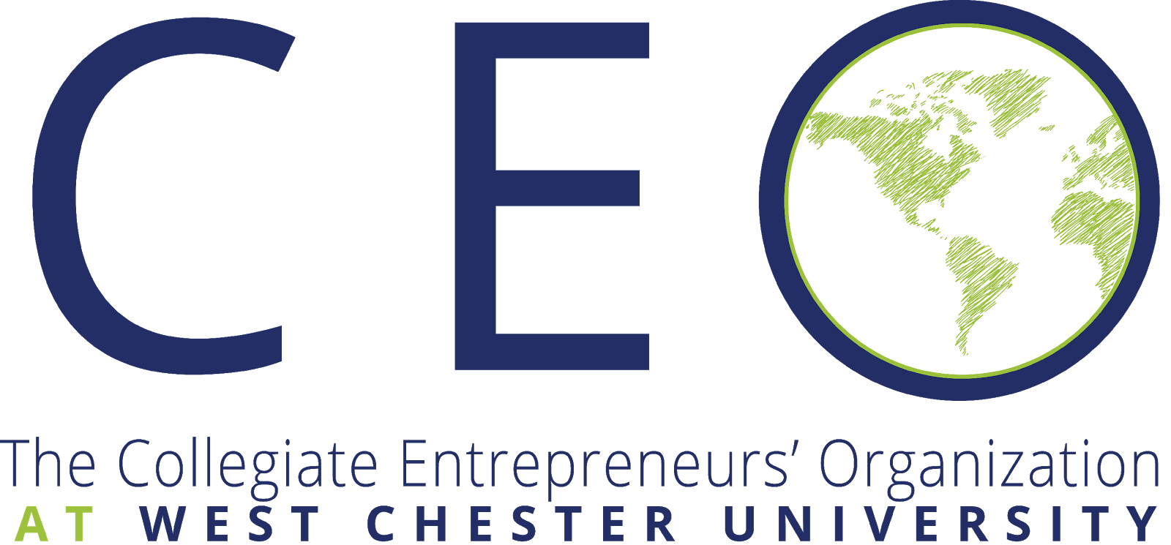
a chapter of

Our Mission
To create a community of aspiring high performing professionals who work together to turn ideas into reality.

Tentative Discussion Topic & Meeting Schedule – Fall 2019
Application for Success
Oct 28 - Organized Planning
Nov 4 - The Value Exchange
Nov 11 - Funding
Nov 18 - Value Proposition & Branding
Dec 2 - Delegation
Dec 9 - Building a self-reliant system

Foundation for Success
Sep 9 - Introduction, What is our goal?
Sep 23 - Habits for Success
Sep 30 - Setting Priorities
Oct 7 - Mastermind Group (Synergy)
Oct 14 - Outwitting Fear & Taking Action
Oct 21 - The Service Paradigm

Benefits Of CEO at WCU
- Membership in West Chester’s new and club member-exclusive Entrepreneurship Club Facebook Group
- Access to a network of global/national collegiate entrepreneurs
- Access to live webinar's featuring successful entrepreneurs
- The Collegiate Entrepreneur newsletter, published quarterly and online
- Chapter speakers, business start-ups, teaching entrepreneurship, internships
- Discounted registration fees to the Global CEO Conference
- Communication on entrepreneurial challenges through the CEO online Social Networking Community
- Student entrepreneur competitions, including the elevator pitch at the national conference
- Chapter development support
- Leadership training
- Discounts on products and services
- Chapter awards
Contact Information
Nicholas Mullin, Entrepreneurship Club President, NM864812@wcupa.edu
Dr. Edwin Cottrell Entrepreneurial Leadership Center
318 Business and Public Management Center
www.wcupa.edu/cottrellcenter
*Check your school email for weekly updates*

