FRE 422-20 & 522-20 / Moscatelli 14-24 May 2018 Time: 4:30-8:00 Room: TBA

Multi forms of Written Expression

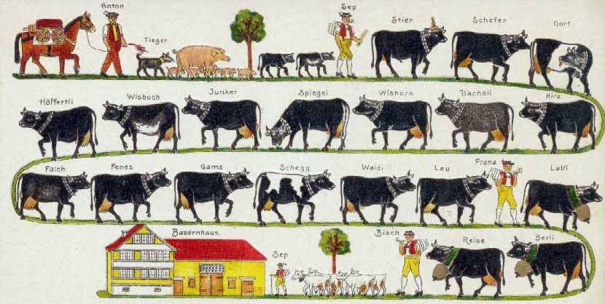
This course will look at various forms of speech: conversational and formal, verbal and non-verbal communicative language, cultural language, argot and verlan secret languages, adolescent reactionary language, boustrophedon writing, proverbs
and what they tell about a culture, mixed languages,versus codified languages.

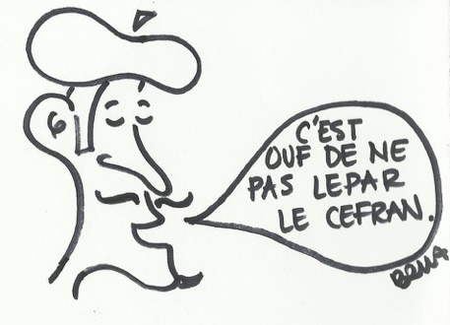
The aim of the course is to develop awareness in the learners of the multi forms of communicative languages and to practice and illustrate them in the structure of a written text. These creations (in French) can take the form of dialogues, play, games, rimes, song, puppet show, etc….

Presentations: on a daily basis, students will present a different topic dealing with a form of communication (written and oral) based on French and francophone cultures.
For their final project, students will create a story using characters who identify with various forms of speech.

