Summer courses 2017 / Moscatelli 14-24 May 2018

315-20 & 520 20 Intensive Oral Practice 8:00-11:30

This summer we will visit, discover or rediscover 9 francophone countries. Each day, students will research and give a presentation on the country selected for that day. The presentations which can be made with power point or not will discuss the following topics: geographical situation, historical background, traditions, languages spoken, music, art and artists…etc… Daily, students will assume a different profession in a town in that country, and share specifics of that profession with the class. You’ll have fun being a baker, a fisherman or a scuba diver (disguises to match the profession & tools of the trade highly recommended). The countries we will visit are the following:
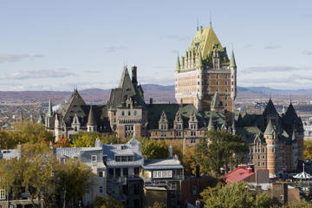
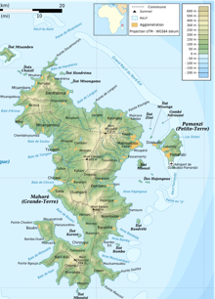
15 May: France
16 May: Québec
17 May: Saint Pierre et Miquelon
18 May: Morocco
19 May: Bénin
22 May: Mayotte
23 May: Tahiti and Nouméa
24 May: Guyana
25 May: Guadeloupe.

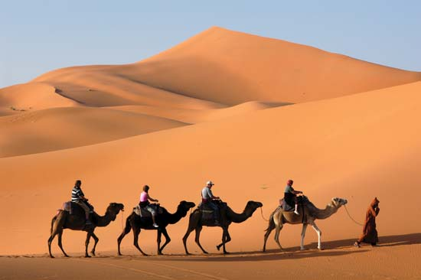
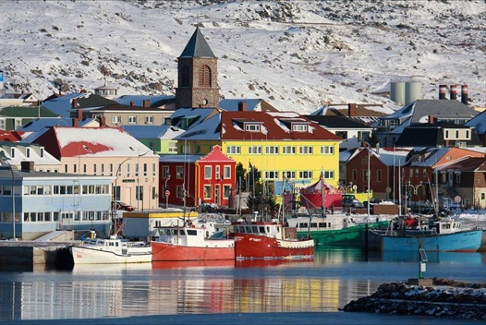
This is an intensive course, only offered in the summer for 9 consecutive days. It aims at developing a functional speaking ability i.e., the ability to communicate verbally in a practical and accurate way in French. Students enrolled in the course will have the opportunity to apply the linguistic knowledge of French to various new contexts dictated by the different environment of the countries visited. They will develop and apply the French language to new situations (the daily professions), in as realistic a context as possible. This course will be enriched with movie clips, songs, games and problematic situation to solve in a fun non-threatening environment. For additional information, feel free to contact Dr. Moscatelli (office MIT 237; email: amoscatelli@wcupa.edu

