Reporting Guidelines
Please complete this form and submit via email within 30 days of the completion of the program/event to Trudy Cruice at gcruice@wcupa.edu and copy Dr. Matthew Bricketto (mbricketto@wcupa.edu).
- *Budget: Please include expenditures from these grant funds only. See the sample below for assistance. Include how you paid for each expense (e.g. cost center or p-card), a description of the expense, what was budgeted initially, what was actually spent, and descriptive comments if necessary.
Sample
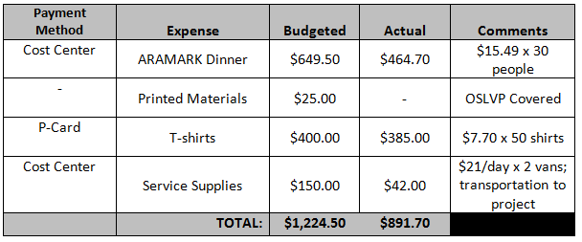
Payment Method | Expense | Budgeted | Actual | Comments
 | Total:

- Learning Outcomes: What did participants gain from this program/event?

- Participation Rates: How many students were involved?

- Photos, Videos, or Articles: If applicable, please include photos from the program/event as an attachment when submitting this form via email. Links to videos or news articles can be included in the space below.

- *Receipts: Please include documentation for every purchase made with these grant funds as an attachment when submitting this document. Please indicate that you have documented these purchases and will include verification of every purchase with this form.

Yes, I understand.

