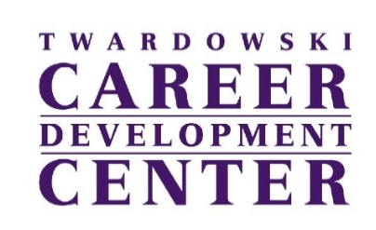
cdc@wcupa.edu ● 610-436-2501 ● wcupa.edu/cdc

Information Interview Assignment
Utilizing Ram Nation, WCU’s alumni-to-student mentoring platform, students will connect with alumni to complete an information interview. Assignments are designed to be both plug-and-play and customizable, so it can be used as is, or modified to work for you and your students.

Learning Outcomes [NACE Career Competencies]
- Students will navigate the Ram Nation platform to identify and make contact with an alum for an informational interview. [Technology]
  - Assessed by student’s completion of the assignment using the Ram Nation platform.
- Students will demonstrate the ability to independently and effectively develop 4 questions for an informational interview before connecting with an alum. [Communication]
  - Assessed by student’s ability to hand in questions that are appropriate for an informational interview.
- Students will reflect on the information they receive during the informational interview and create one short-term goal that aligns with their personal or professional development. [Career and Self Development, Communication]
  - Assessed via the assignment rubric

Contents:
- Student Assignment – page 2
- Grading Rubric – page 3

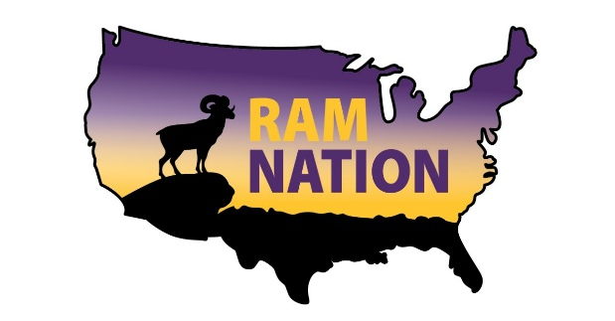
Informational Interview Assignment

The Assignment

Reach out to a WCU alum through Ram Nation (ramnation.wcupa.edu), WCU’s alumni-to-student mentoring platform, and request a 30-60 minute informational interview via zoom, phone, or in person. Step by step instructions on how to do this can be found here.

There are three items that must be turned in to receive credit for this assignment.
- At least 4 questions that you asked during the informational interview
- A screen shot of the thank you email you sent the alum after meeting
- A brief essay (900-1,000 words), where you reflect on and summarize the key content of the interview, sharing how the discussion can inform your next steps or choices going forward, and sharing at least one short-term goal for continuing your personal and professional development journey.

Learning Outcomes [NACE Career Competencies]

- Students will utilize the Ram Nation platform to identify and make contact with an alum for an informational interview. [Technology]
  - Assessed by student’s completion of the assignment using the Ram Nation platform.
- Students will demonstrate the ability to independently and effectively develop 4 questions for an informational interview before connecting with an alum. [Communication]
  - Assessed by student’s ability to hand in questions that are appropriate for an informational interview.
- Students will reflect on the information they receive during the informational interview, and create one short-term goal that aligns with their personal or professional development. [Career and Self Development, Communication]
  - Assessed via the assignment rubric

Additional Resources for Completing the Assignment

Check out these resources if you need some assistance getting started:
- Ram Nation How-To
- Sample Informational Interview Questions
- What Should I Say?
- How Do I Start?
- I Connected, Now What?
- This Feels Scary

Questions about the Ram Nation platform? Email the Career Center at cdc@wcupa.edu.

Ram Nation Informational Interview Assignment Rubric

Learning Outcome #1: Students will utilize the Ram Nation platform to identify and make contact with an alum for an informational interview. [Technology]
___ Student completed the informational interview through Ram Nation (2 points)

___ Student did not complete the informational interview through Ram Nation (0 points)

Learning Outcome #2: Students will demonstrate the ability to independently and effectively develop 4 questions for an informational interview before connecting with an alum. [Communication]
___ Student handed in at least 4 questions that were asked during the informational interview (2 points)

___ Student handed in 1-3 questions that were asked during the informational interview (1 point)

___ Student did not hand in any questions that were asked during the informational interview (0 points)

Learning Outcome #3: Students will reflect on the information they receive during the informational interview and create one short-term goal that aligns with their personal or professional development. [Career and Self Development, Communication]

 | 3 | Excellent | 2 | Satisfactory | 1 | Not Satisfactory | 0 | Did Not Complete
Evidence of Reflection | Completed the assignment and writing demonstrates significant evidence of reflection following the informational interview. | Completed the assignment and writing demonstrates some evidence of reflection following the informational interview. | Completed the assignment but writing does not show evidence of reflection following the informational interview. | Did not complete assignment.
Articulation of Short-term Goal | Completed the assignment and clearly articulated a short-term goal informed by the informational interview. | Completed the assignment and loosely articulated a short-term goal which may or may not have been informed by the informational interview. | Completed the assignment but did not share one short-term goal. | Did not complete assignment.

Evidence of Reflection Score: ___ / 3

Articulation of Short-term Goal Score: ___ / 3

Total Score: ___ / 10

