PDF Error Message
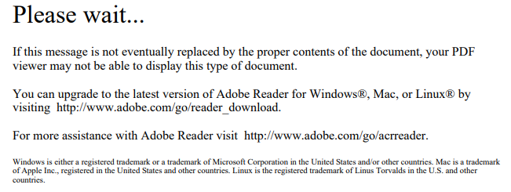
Not all PDF files are the same. This error message occurs when a user attempts to open an interactive PDF in a web-browser that does not support it. (Users will be able to open non-interactive PDF files without any issue.)

Solutions
- Use Internet Explorer which DOES support use of non-interactive PDF files.
- Chrome users have some options:
  - Adobe Acrobat Extension for Chrome
    - Enable the ‘Convert current web page to and Adobe PDF file’ extension. HINT: the extension is already enabled if an Adobe Acrobat icon is visible on the browser. If this is the case, skip to Step 2b to see how to work with the extension.
    - On the browser, click the settings icon to the far right of the menu bar, then choose ‘More tools’ \ ‘Extensions’ in the drop down.
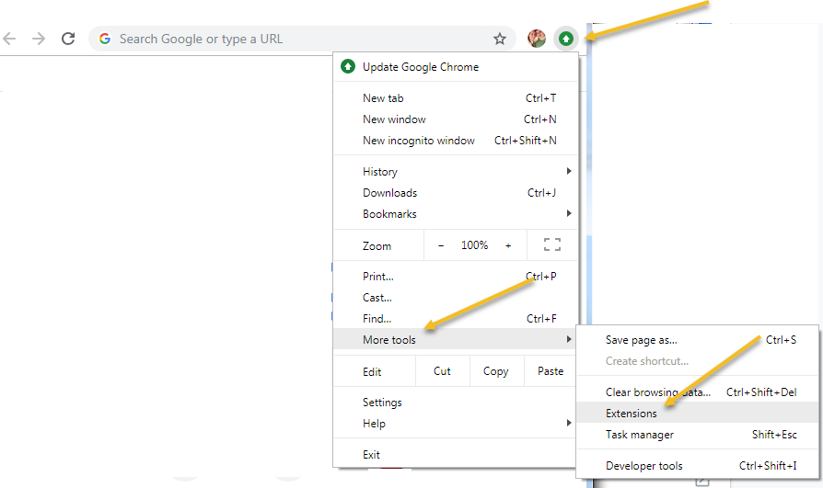
    - Enable the Adobe Acrobat extension
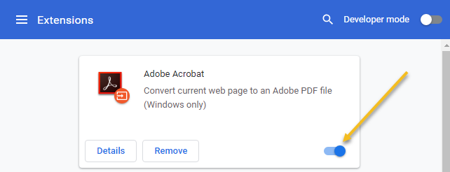
    - Once the extension is enabled, there are two ways to resolve the issue with interactive PDFs
      - Option 1: For the selected file, right click on the hyperlink, then choose ‘Save link as . . .’ which will prompt the user to save the file via the standard Windows dialog.
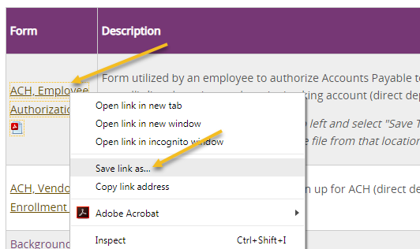

      - Option 2: If the interactive PDF hyperlink throws the ‘Please wait . . . ‘ error message, the user can manually trigger the ‘Convert current web page to PDF’ extension. When the PDF opens, if you see the Adobe Acrobat drop down, simply select the ‘Open in Acrobat’ option.
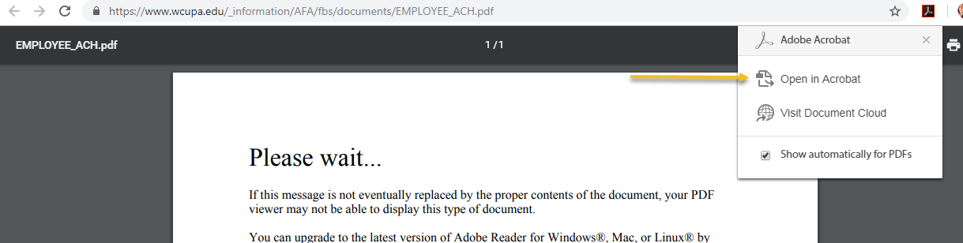

        - If the drop down is not visible,
          - Click the icon to open the drop down manually, then select the ‘Open in Acrobat option’.
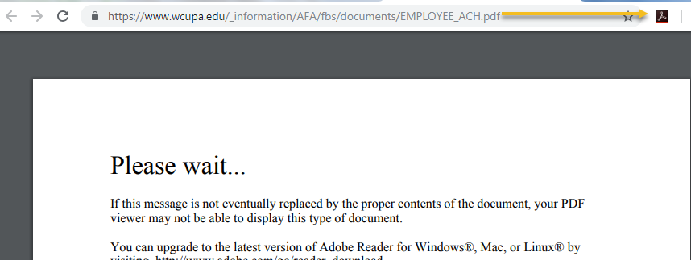

          - Selecting the ‘Show automatically for PDFs’ checkbox will eliminate the step to click the Adobe icon on the browser for the interactive PDFs.
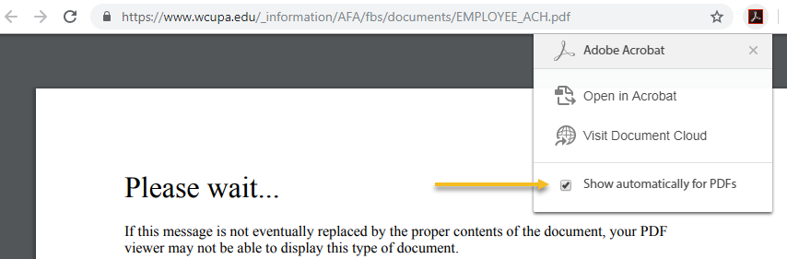

  - Chrome Settings for All PDF Files - Automatically download all PDF files. (NOTE: This solution will apply to all PDF files, not just the interactive PDFs.) To enable this feature:
    - On the browser, click the settings icon to the far right of the menu bar
    - Choose the ‘Settings’ option
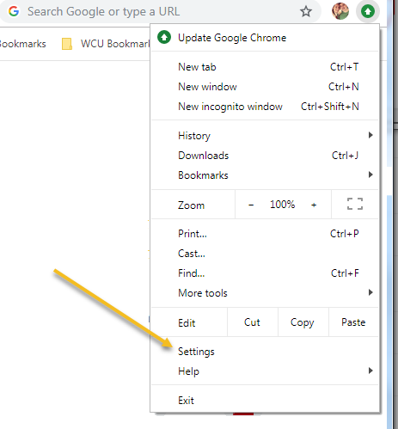
    - When the Settings page opens, go to the bottom, then expand the ‘Advanced’ section.
    - In the ‘Privacy and security’ section, choose the ‘Content settings’ option.
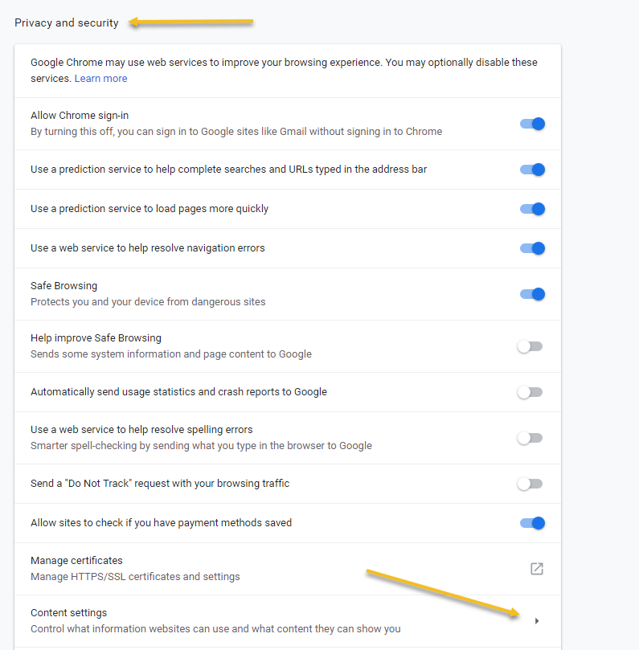
    - Scroll down, then select the ‘PDF documents’ option.
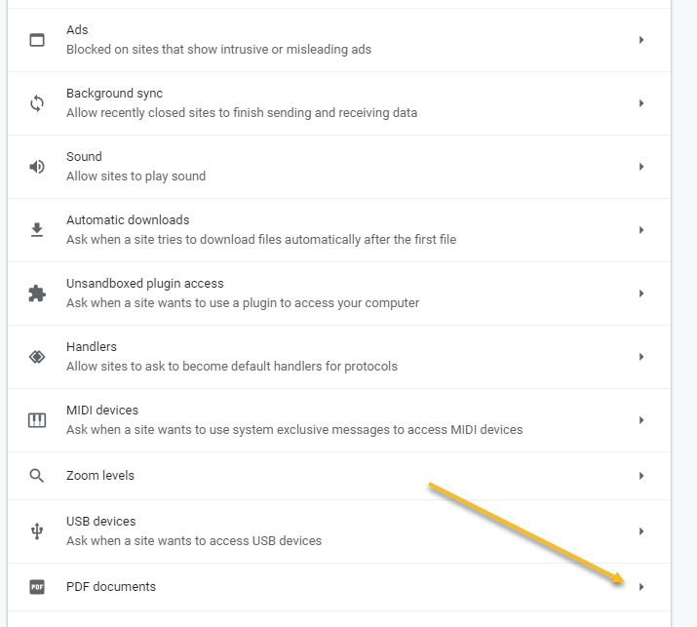
    - Turn on the ‘Download PDF files . . .’ option.
