
Reynolds Hall

650 Reynolds Alley
Built: late 1800s | Size: 6,313 sf
Acquired: 1948 | Condition: Good
Last Renovation: 1996 | Function: E&G

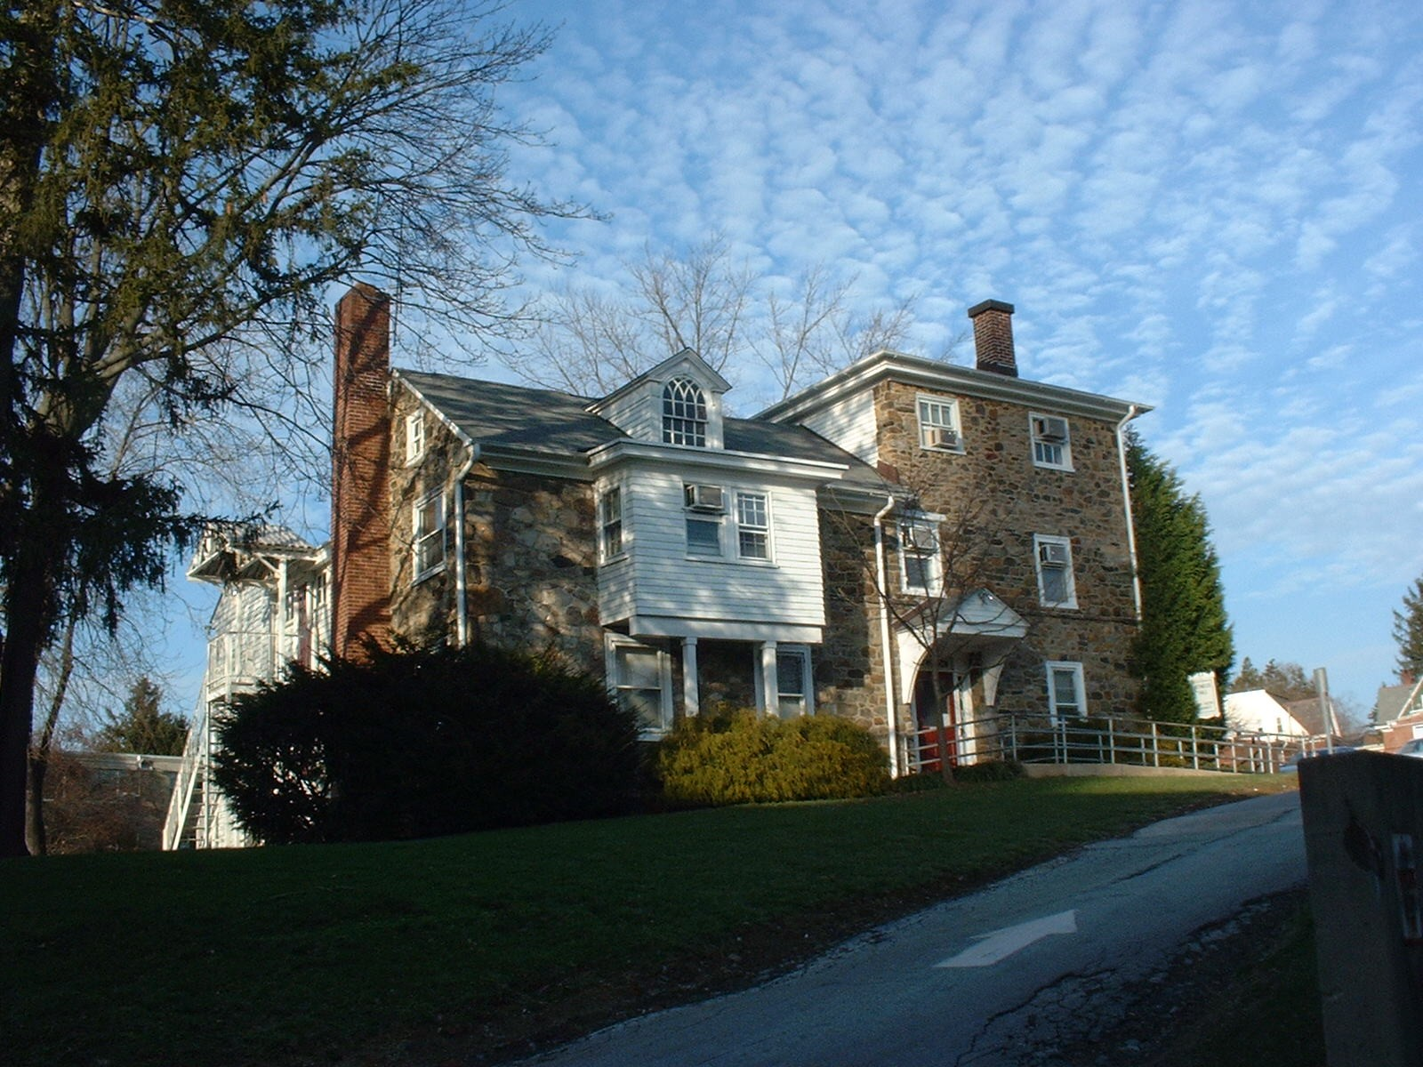

Once a private home and initially occupied by the University in 1948, Reynolds Hall now houses the Graduate Social Work Department. The building is located in the back corner of the parking lot behind 25 University Ave and Mitchell Hall.

Present Use: Faculty office space.

Disability Access: 1st floor only, thru side accessible entrance. Accessible restroom.

Past Projects: 1996 Renovation, 1998 Roof

Scheduled Projects or Capital Renovations: None

Description of Construction: Stone masonry foundation, shingle roof, masonry stone exterior walls, wood floors. Shingle and raised-seam tin roof.

Condition and Use Assessment:
Deferred Maintenance (2007): $ 180,000 | Est Replacement Cost (2007): $ 1,355,000
Facility Condition Index: 0.133 | Deficiency/SF: $ 28.15
Yearly Electric Use Cost: $ | Yearly Water Use Cost $

