
FH Green Library, Phase- II

25 W. Rosedale Avenue
Built: 1976 | Size: 86,009
Acquired: N/A | Condition: Fair
Last Renovation: | Function: E&G
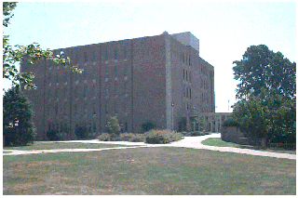
The six-story Francis Harvey Green Library (Phases I & II) sits prominently upon the knoll on the northwest corner of West Rosedale Avenue and South High Street. It was constructed in two phases, a two story structure in 1966, and this six story addition in 1976. Essentially, the building operates as two separate structures, with separate mechanical systems and life-cycle
repairs. The entrance of the library faces the Quad, putting its back to the street.
The library is furnished with a variety of seating areas, including individual study
carrels, faculty and graduate lounges, group study areas, seminar rooms, and general
reading areas. Its total resources number more than 874,000 volumes. A number of
historical collections are housed in the Special Collections Room on the sixth floor.

See Francis Harvey Green Library, Phase I, for additional comments. PASSHE criteria for libraries validate the expansion of the FHG Library to support the number of holdings in the library and the number of students attending the University. Student surveys over the past several years have shown a rather significant decline in their satisfaction with the library. Substantial improvements are required to restore it to a quality facility.
Present Use: Library facility

Disability Access: Full, with elevator and accessible restrooms on 2nd and 6th floors.

Past Projects: Handicapped parking lot - 1991, ADA Restrooms and Elevator upgrade 2003, Façade repairs 2005.

Scheduled Projects or Capital Renovations: A Capital Project totaling $18.5 million has been authorized by the Legislature in 2000, but this project amount has quickly been outdated, and other campus priorities remain.

Description of Construction: Reinforced concrete foundation, built-up roof, masonry brick veneer exterior walls, concrete slab floors.

Condition and Use Assessment:
Deferred Maintenance (2007): $ 900,000 | Est Replacement Cost (2007): $ 19,390,000
Facility Condition Index: 0.05 | Deficiency/SF: $ 10.46
Yearly Electric Use Cost: $ | Yearly Water Use Cost $

