myWCU Advising notes instructions

The WCU Advising Task Force endorses the best practice of keeping easily-accessible notes of advising meetings to remind students of what they should do after meeting with their advisors and to create a historical record. myWCU now allows advisors to enter electronic notes that will attach permanently to a student’s record. By maintaining electronic advising notes, students can access the advice you have provided at any time and from anywhere; additionally, if advisors need to be reassigned (because of sabbatical leave or other reasons), or if a student has more than one advisor (for example, dual degree advisors or minor advisors), all advising recommendations will be transparent and easily transferred. There is no length maximum for these notes.

It is strongly recommended that all campus advisors use this new functionality to improve advising.

This manual will cover:
- Adding an advising note
- Note categories
- Adding attachments
- Adding action items
- Completing your note
- Notifying students of notes
- Adding updates to notes
- “Filtering” to see only certain notes

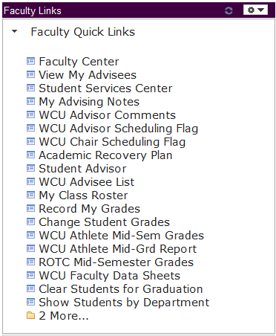
1. Adding an advising note
Advising notes can be accessed in myWCU. Click on “Faculty Quick Links” followed by “View My Advisees.”

You will be taken to a page of all of your current advisees. To add an advising note, click on the note icon in the last column.
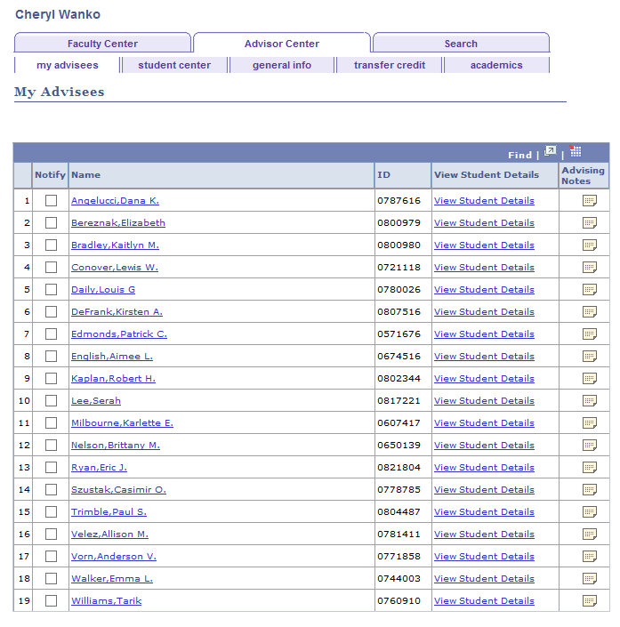

This page will show you all of the advising notes that have been entered for the student. To add note, click “Create a note.”
You can look at another student’s notes by using the “Change Advisee” dropdown.

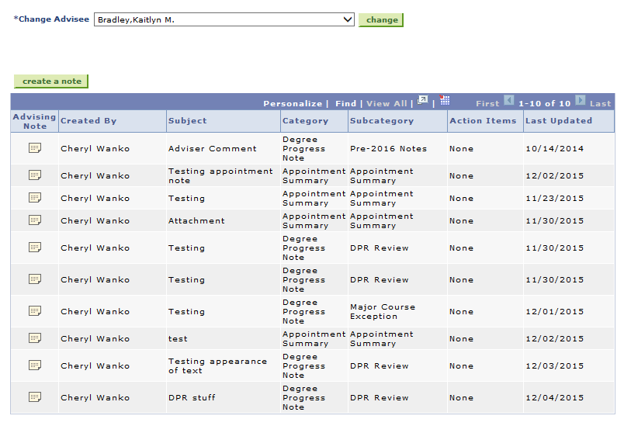

The “Institution” field will automatically populate.

2. Note categories
Then you must select a category and subcategory. Every note MUST have a category and a subcategory, selected from the dropdown. The two main categories and their subcategories are described below.

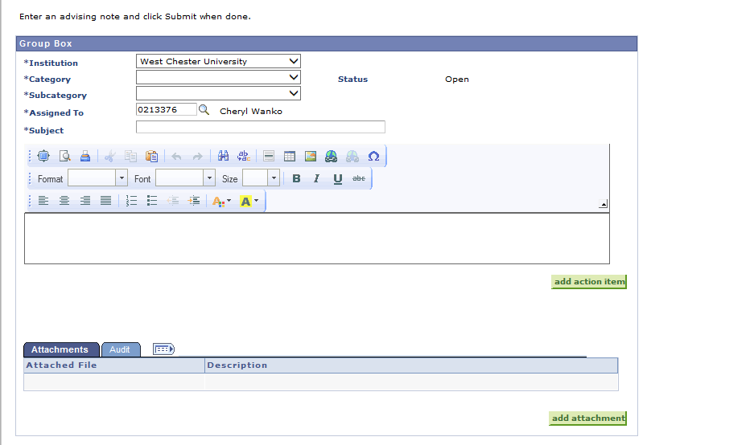
Enter Text HEREHERE

Appointment Summary: This is used for notes that summarize appointments. Notes in this category should NOT address course substitutions or requirement waivers. They will NOT appear on the degree progress report (DPR). Use the subcategory that best describes the appointment topics – they may be handy for tracking ongoing conversations later.

Subcategories
- Major Appointment Summary - use this to indicate that you spoke mainly about topics related to the student’s major (and gen ed) at your meeting.
- Minor Appointment Summary - use this to indicate that you spoke mainly about topics related to the student’s minor at your meeting.
- Generic Appointment Summary – use this if you spoke about a mix of topics or about topics not immediately connected to major or minor.

Degree Progress Note: Notes in this category will appear on the DPR. Course substitutions and exceptions should be placed in this category.

Subcategories
- DPR Review – used for general review of or comments on the DPR.
- Major Course Exception – after consulting with university and department policy (and, if necessary, your chair), indicate major course substitutions under this category.
- Minor Course Exception – after consulting with university and department policy (and, if necessary, your chair), indicate minor course substitutions under this category.

3. Adding attachments
You can add attachments to your notes – for example, if you use a hard copy advising sheet, you can scan it and attach it to the notes for your conversation. Click “Add Attachment.” Select and upload your file. The file will be attached to the note after you click “Submit.”

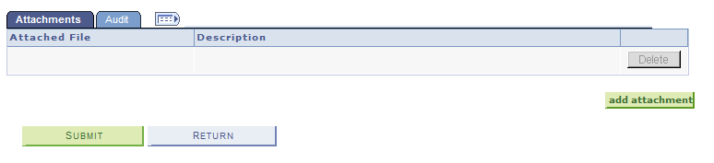

4. Adding action items
Sometimes you want to remind either you or the student to take a certain action by a certain date; for example, you might need to check a policy, or you might direct your advisee to visit the Career Center. Use an “action item” to keep track of these needs or recommendations. This function is optional. Enter a description, a status, and a due date.

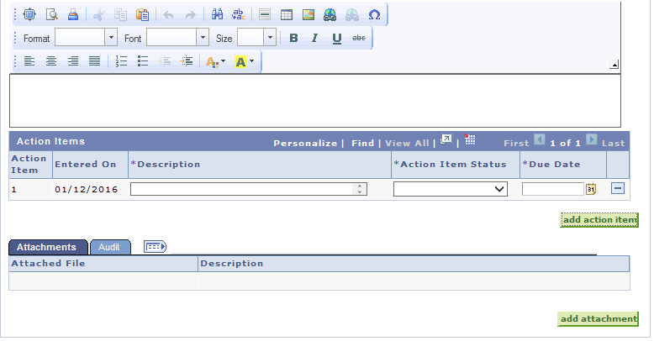

Incomplete action items will appear on your and the student’s home page of myWCU.

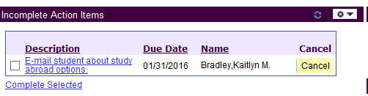

Action items can be completed or cancelled on the home page of myWCU.

5. Completing your note
When you are finished typing your note plus adding any attachments and/or action items, click “Submit.” The following warning will appear:

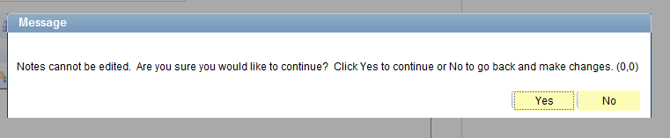

Once you click “Yes,” the note cannot be edited or removed from the student’s record. However, you may add updates to this note by following the instructions below.

6. Notifying students of notes
Students will NOT automatically know that a note has been added to his/her record. If you want to notify the student that a note has been added, click on “Notify Advisee.”

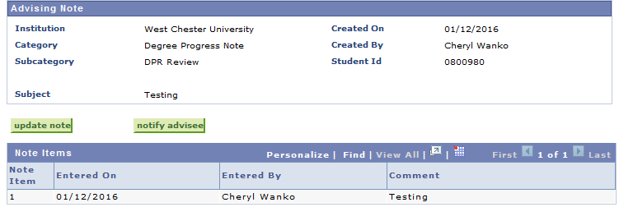

Students will NOT be notified that there is a new advising note unless you use this “Notify Advisee” function.

You can add explanatory text before sending the e-mail notification to the student:
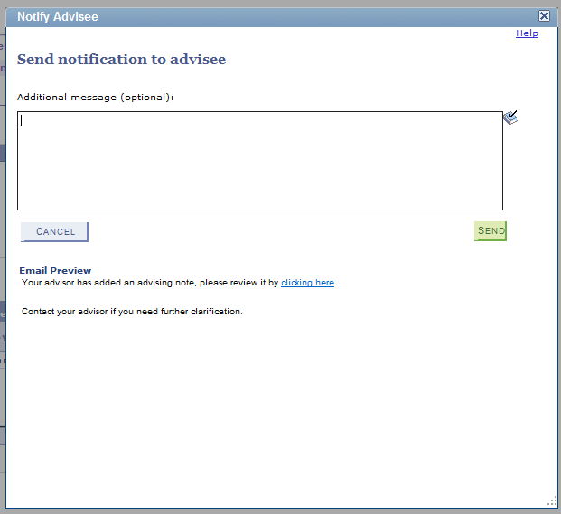

7. Adding updates to notes
If you want to add later information to a prior note, go into that note and click on “Update Note” to add an update. Updating a note will “link” the update to the original note:

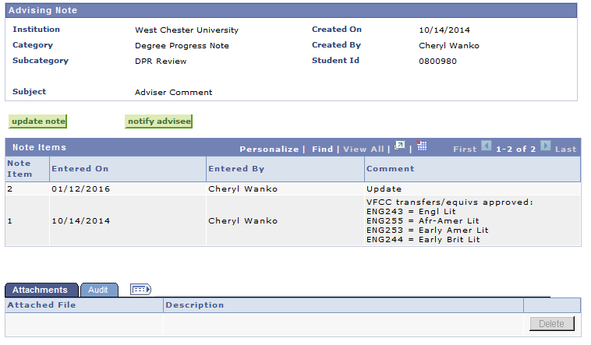

8. “Filtering” to see only certain notes
You may only want to show notes created in the last week, or only notes with updates (etc.). To filter for such criteria, go to Faculty Quick Links My Advising Notes (see the first screen shot of these instructions, page 2).

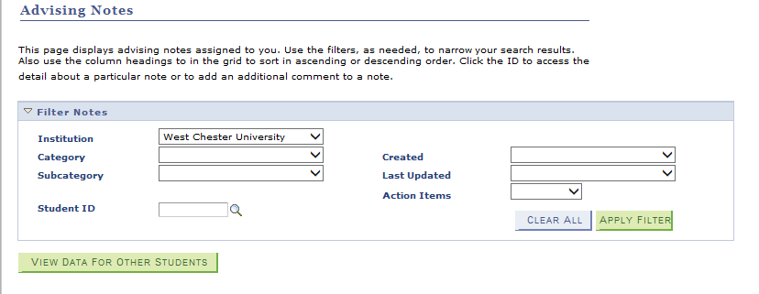

The “Institution” field will automatically populate. You can enter criteria for one or more of the other fields and click on “Apply Filter.”

Leaving all fields blank and clicking on “Apply Filter” will show you all of the notes you have placed on any student’s record.

