
Old Library

775 S. Church Street
Built: 1902 | Size: 22,355 sf
Acquired: N/A | Condition: Poor
Last Renovation: | Function: E&G

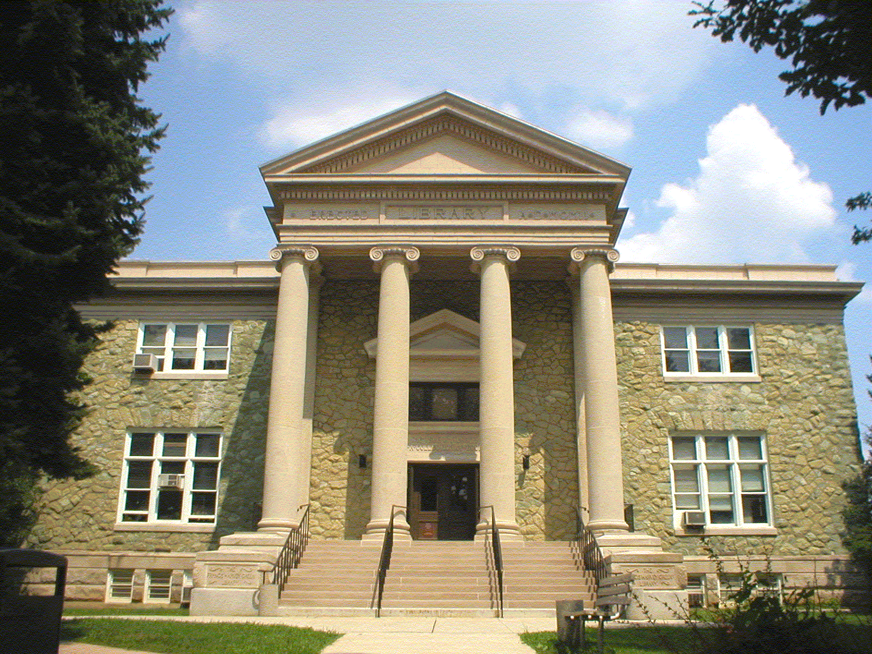

The Old Library is on the prominent corner of South Church Street and West Rosedale Avenue, marking the southwest corner of the Quad. Following the old tradition of the Quad, this 1902 building is constructed from serpentine rubble stone and topped with a slate roof. The Department of Anthropology and Sociology, and the Frederick Douglass Institute are housed in this facility.

The Old Library is included in the Quadrangle Historic District. It has been entered in the National Register of Historic Places.

Present Use: Academic classrooms and faculty office space.

Disability Access: None

Past Projects: 1992- Nursing Lab, 2000 Roof, 2008 Fire Alarms

Scheduled Projects or Capital Renovations: A $4.7 million Capital Request Authorization has been filed for the complete life-cycle renovation of this building.

Description of Construction: Concrete foundation, built-up roof, masonry stone veneer exterior walls, concrete and wood floors.

Condition and Use Assessment:
Deferred Maintenance (2007): $ 490,000 | Est Replacement Cost (2007): $ 5,243,000
Facility Condition Index: 0.093 | Deficiency/SF: $ 21.92
Yearly Electric Use Cost: $ | Yearly Water Use Cost $

