
Merion Hall

720 S. Church Street
Built: 1995 | Size: 73,888 sf
Acquired: N/A | Condition: Excellent
Last Renovation: 2003 | Function: E&G

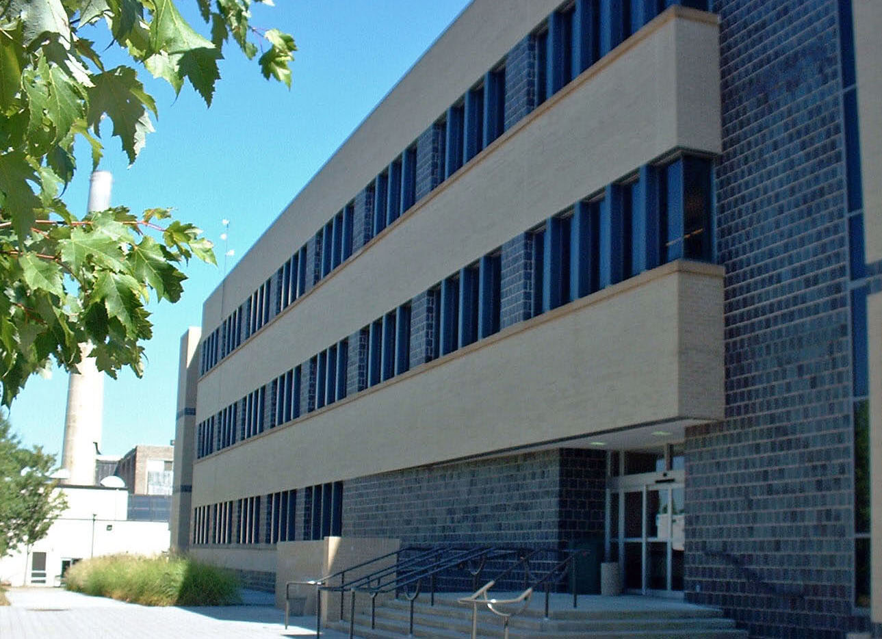

Merion Hall is one of the newer buildings on the campus. The facility adds 74,000 SF of modern science space to the Schmucker Science Center. The building features modern science labs, individual faculty research spaces, animal research spaces, multi-media lecture rooms, a greenhouse, offices and specialized facilities for the Physics Department. Three new classrooms have been added to this building during the Schmucker I (North) renovation in 2003.

Present Use: Science laboratories, classrooms, faculty/staff office space. Geology and Astronomy, Physics and Biology Departments utilize the facility.

Disability Access: Full

Past Projects: 1994 Roof, 2003 Classrooms (3) Addition

Scheduled Projects or Capital Renovations: None

Description of Construction: Reinforced concrete foundation and structure, combination block and brick exterior walls, built-up roof.

Condition and Use Assessment:
Deferred Maintenance (2007): $ 200,000 | Est Replacement Cost (2007): $ 23,397,000
Facility Condition Index: 0.001 | Deficiency/SF: $ 0
Yearly Electric Use Cost: $ | Yearly Water Use Cost $

